July 10, 2026

Applicability: Robinson

Internal Release Information:
F2026-016 Robinson
Created a new sub-format for a Foldout section that uses a smaller font size.

- [Check this box if a sql query or a data fix applies to this update].

Generic External Release:
N/A

Plant Specific Information for Release Letter:
Robinson
An additional format for Foldout sections that uses a smaller font size. The format name is “Robinson 9pt DUPLEX FOLDOUT FORMAT”.

Testing Requirements:
Use Robinson data
- Update format files
- Exit PROMS and run PROMSFixes in SQL (this will allow PROMS to see the new format)
- Edit the properties for the Foldout section for AOP procedure AOP-020 and change the format to the “Robinson 9pt DUPLEX FOLDOUT FORMAT”.

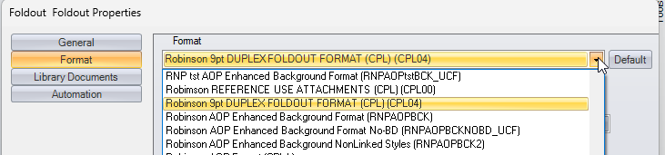

- Print the procedure and version the Foldout section has all 8 foldout steps

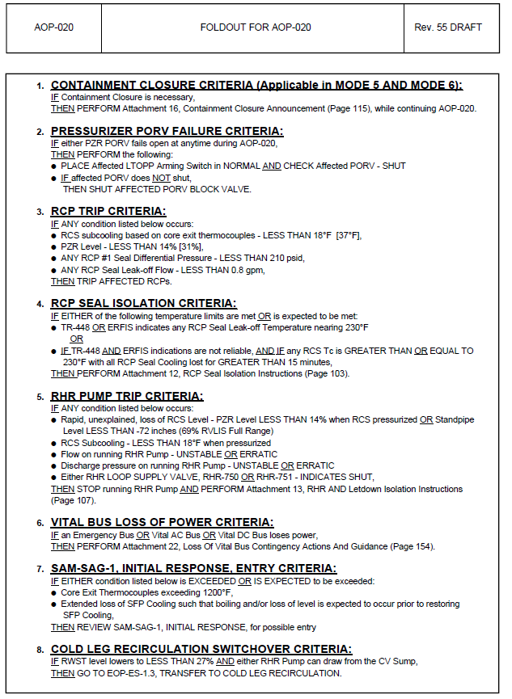

Changes/Additions to PROMS Manual and Training Videos:
[Do not use this section – for MRV/DMJ use]
- CSM submitted for PROMS User Manual: ____________.
- CSM submitted for training videos: ____________.

