January 24, 2025

Applicability: All Plants

Internal Release Information:
C2025-008 RO Editor – Remove redundant Save Failed message box

In the RO Editor when saving a new RO and the correct fields have not been filled out, It currently has 2 message boxes come up. The first box says that the save failed and provides details – while the second message box simply states “Save Failed” with no details. This is redundant, so this is to remove the 2nd message box.

Note: There is a note on the CSM item referencing D.2.9 in the PROMS Manual

- [Check this box if a sql query or a data fix applies to this update].

Generic External Release:
In the RO Editor, removed a redundant message when saving ROs and not specifying needed fields.

Plant Specific Information for Release Letter:
N/A

Testing Requirements:
- Use any RO db
- Add a new RO (like a setpoint)
- Attempt to Save without providing a needed field (like Setpoint ID)
- Should only receive one Save Failed message box which provides some details on a missing required field.
- For example:
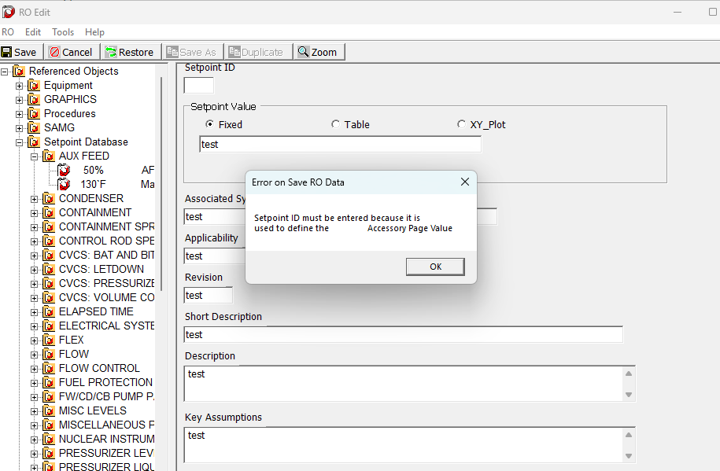

Changes/Additions to PROMS Manual and Training Videos:
[Do not use this section – for MRV/DMJ use]
- CSM submitted for PROMS User Manual: ____________.
- CSM submitted for training videos: ____________.

