2/26/2024

Applicability: B2024-011: Barakah Export/Import of procedure incorrectly imports unit information ROs in tables so that they are not resolved when printed

Internal Data Fixes: NA

Internal Release:

B2024-011: Barakah Export/Import of procedure incorrectly imports unit information ROs in tables so that they are not resolved when printed. The newer RO handling code was changing the default for unit information ROIDs to end in 0041 versus 0000, but ROID stored for the RO in the table did not have the new default. The code could not set the correct rousageid in the link text within the table data for the RO since it could not find the ROID. The code in dlgExport.Import.cs was modified to check for this.

Generic External Release: NA

Plant Specific Information for Release Letter:

Barakah: A problem with importing of Unit Information Referenced Objects in tables was fixed. When printing, these Referenced Objects were not getting resolved for the unit number selected. Note that if the unit information referenced object cannot be resolved during the import process, running of the Administrative Tools/Links/Check RO Links can be used to determine where these are located and will place an annotation on those steps. These will have to be reentered manually.

Testing Performed:

See Testing Required.

Testing Requirements:

Using the Barakah sql database:

£ Export ST/s OP-ST-XX-0012
£ From ST/Working Draft, Import the procedure exported from first step
£ Print the imported procedure and select to print for Unit 1. Verify that the Unit Information ROs are resolved in Attachment 1/Step 42 (in the image below these are in the table as ‘U2’ and ‘U1’, before the fix these had a list of unit numbers):

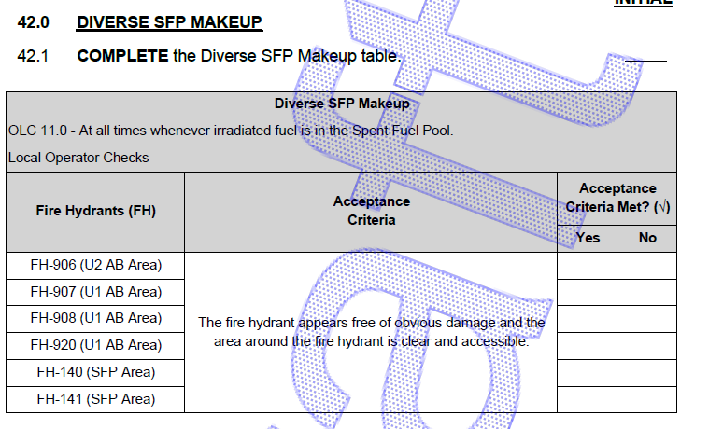

Changes/Additions to User Documentation: NA

