May 29, 2026

Applicability: GEN

Internal Release Information:

C2026-021 Expand Functionality of Viewing Mode
Upgrade - When using Parent Child - in the Side Properties on the Applicability tab, there is a "Viewing Mode" option ---- this currently only impacts the CAS/CTS / Summary of Changes / Display History. Expand this so that when a particular unit is selected, it resolves the unit to that specific unit in the UI and shows change bars in the UI based on that specific unit.
\
B2026-048 View Only Mode
If only one tab is Open in PROMS and that tab is in View Only Mode - if you close that tab and then attempt to re-open the procedure, PROMS freezes after the procedure re-opens.

- [Check this box if a sql query or a data fix applies to this update].

Generic External Release:
When using Parent Child - in the Side Properties on the Applicability tab, there is a "Viewing Mode" option. Expanded the functionality of this feature so that when a particular unit is selected, it resolves the unit to that specific unit in the UI and shows change bars in the UI based on that specific unit.

Plant Specific Information for Release Letter:
None

Testing Requirements:
B2026-048 View Only Mode
- Use Any Data
- Open exactly 1 Procedure
- Toggle that Procedure into “View Only Mode” via the Ribbon -> View Tab
- Close that Procedure
- Reopen that procedure
- Should be able to Navigate inside procedure / PROMS should not be frozen

C2026-021 Expand Functionality of Viewing Mode
- Use Any Data with Multiunit
- Add <U-ID> to a step
- Add a RO for “Unit Information - Number” to a step
- Add a RO with different text for Unit 2 to a step
- Approve one of the Units
- In Step Properties -> Applicability -> Viewing Mode, select one of the units
- If you are not in View only Mode already, will get the pop-up
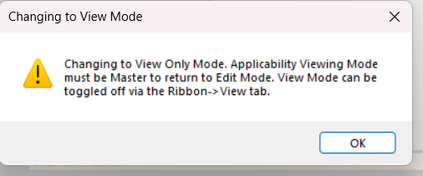
- Edit Window should be in View Only Mode (click on a step and attempt to type in it)
- Text should show Unit based text (matching print)
- Change Bars should match the Unit Specific change bars (i.e. Unit approved would not have change bars while other unit would) (matching print)
- If attempt to swap out of View Only Mode while viewing unit text, should not be able to / get popup:
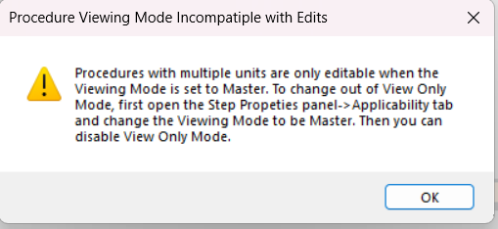
- After Viewing mode is changed back to Master, should be able to swap out of View Only Mode

Test Alarms
- Use Barakah Data
- Open ARPs -> Unit Specific MCR Alarms -> OP-ARP-DA-0001 -> DA-UA-001-11
- In Step Properties -> Applicability -> Viewing Mode, select each of the units, checking the Alarms data reflects the specific unit

Changes/Additions to PROMS Manual and Training Videos:
[Do not use this section – for MRV/DMJ use]
- CSM submitted for PROMS User Manual: ____________.
- CSM submitted for training videos: ____________.

