August 11, 2026

Applicability: All

Internal Release Information:
C2026-039 If a procedure stopped printing during the baseline printing process, when you try to open the file to do a compare you will get a SystemInvalidOperationException.

- [Check this box if a sql query or a data fix applies to this update].

Generic External Release:
N/A – This is internal for baselines.

Plant Specific Information for Release Letter:
N/A

Testing Requirements:
- Run the updated baseline program.
- In the first Browse button navigate to the location for
20260610_0639_2.2.2502.2808_VEPROMS_BGE_39thru69
- In the second Browse button navigate to the location for:
20260612_0548_2.3.2606.510_VEPROMS_BGE_39thru70
- Select the first SAMG procedure set.
- Click the Baseline Button.
- Click on the first page in the left results panel and vrify that you do not get the System.Invalid.Operation.Exception message box with the message “Sequence contains no elements”.

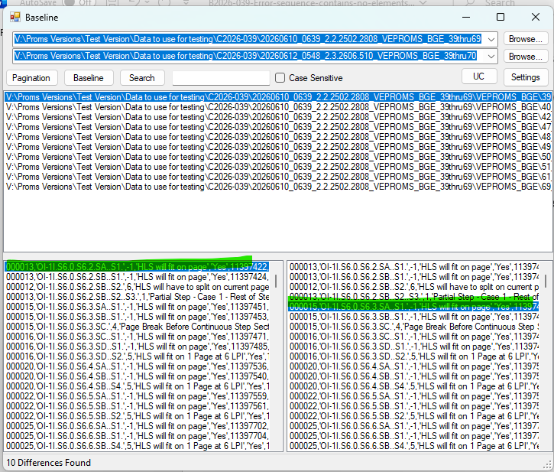

Changes/Additions to PROMS Manual and Training Videos:
[Do not use this section – for MRV/DMJ use]
- CSM submitted for PROMS User Manual: ____________.
- CSM submitted for training videos: ____________.

