April 5, 2024

Applicability: Generic EOP (ERG) format

Internal Data Fixes: N/A

Internal Release:

F2024-052
Beaver Valley Two Column Format. Allow Notes and Cautions off of sub-steps.

Generic External Release:

N/A

Plant Specific Information for Release Letter:

Beaver Valley
The Two Column Format used for the EOPs will now allow adding Notes and Cautions to sub-steps.

Testing Requirements:
Use ERG Rev 4 data
- Update formats
- Edit an EOP procedure and add a Note to a sub-step and a Caution to another sub-step.
- Print and verify the added cautions and notes print

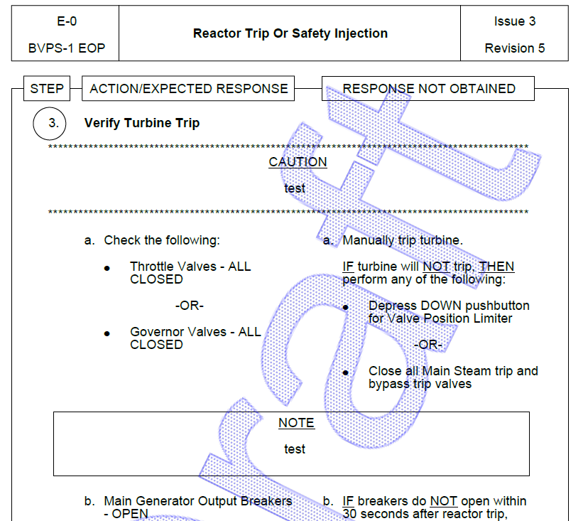

Changes/Additions to User Documentation:

N/A

