April 24, 2024

Applicability: PROMS User Manual

Internal Data Fixes: N/A

Internal Release:

F2024-056
Centered the AND and OR separators in the PROMS User Manual single column format.

Generic External Release:

N/A – internal use

Plant Specific Information for Release Letter:

N/A – internal use

Testing Requirements:
Use the PROMS User Manual data
- Update formats
- Print procedure C.1
- Verify, in step C.1.3.2, the OR separator is centered with respect to location and width of the OR sub-step

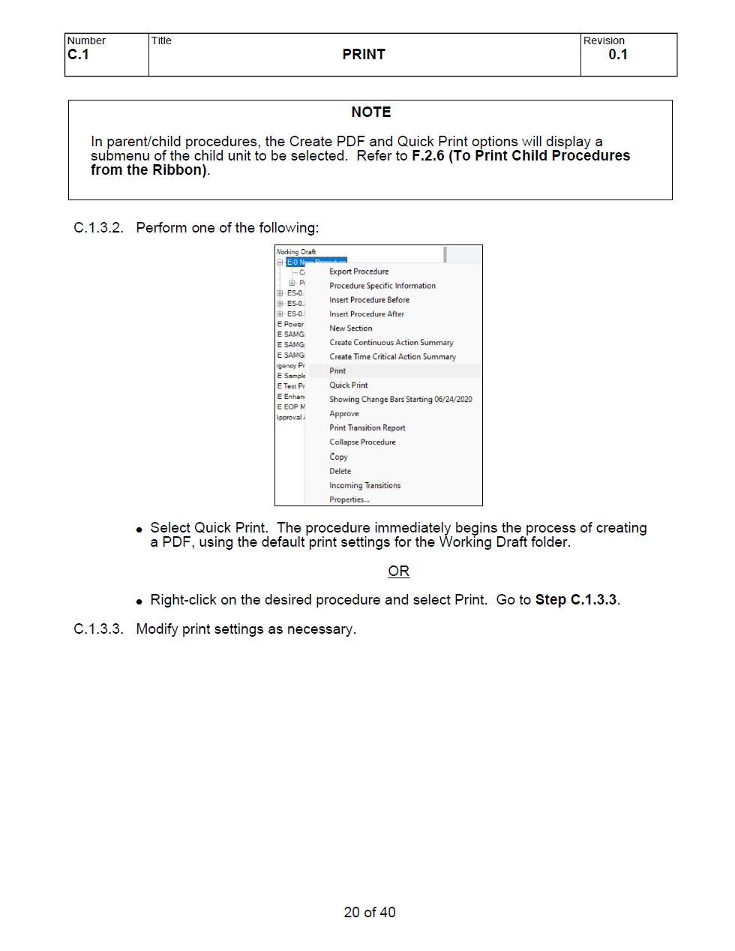

Changes/Additions to User Documentation:

N/A

