March 4 2024

Applicability: Vogtle Units 3 & 4 and Generic

Internal Data Fixes: N/A

Internal Release:
B2024-013
Fixed issue where hard returns are replaced with semi-colons in section titles in Automatic Table of Contents and will use the hard return when printing the section title for Vogtle’s Units 3 & 4 formats.

Generic External Release:

Print
PROMS will now replace a hard return with a space instead of a semi-colon on Automatic Table of Contents

Plant Specific Information for Release Letter:

Vogtle Units 3 & 4
- PROMS will now properly handle hard returns in section titles when printed, instead of replacing them with a semi-colon.
- PROMS will now replace a hard return with a space instead of a semi-colon on Automatic Table of Contents

Testing Requirements:
Use Vogtle Units 3 & 4 data
- Edit the section title for Attachment 10 in local Alarm procedure DWS-ARP-010 and add a hard return to the title

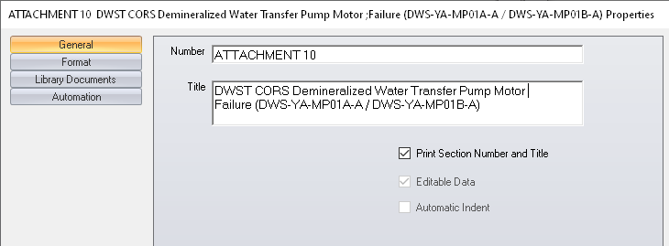

- Print the procedure
- Verify the section title does not have a semi-colon where the hard return was on the Table of Contents.
- Verify the section title raps at the hard return on the printout of Attachment 10

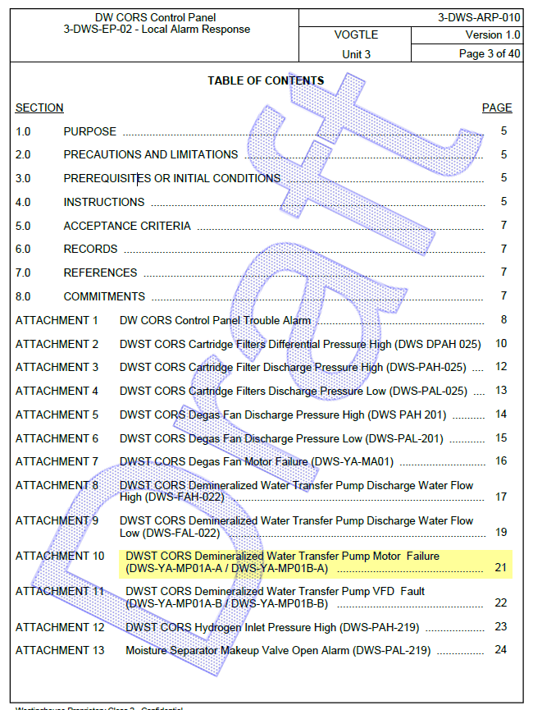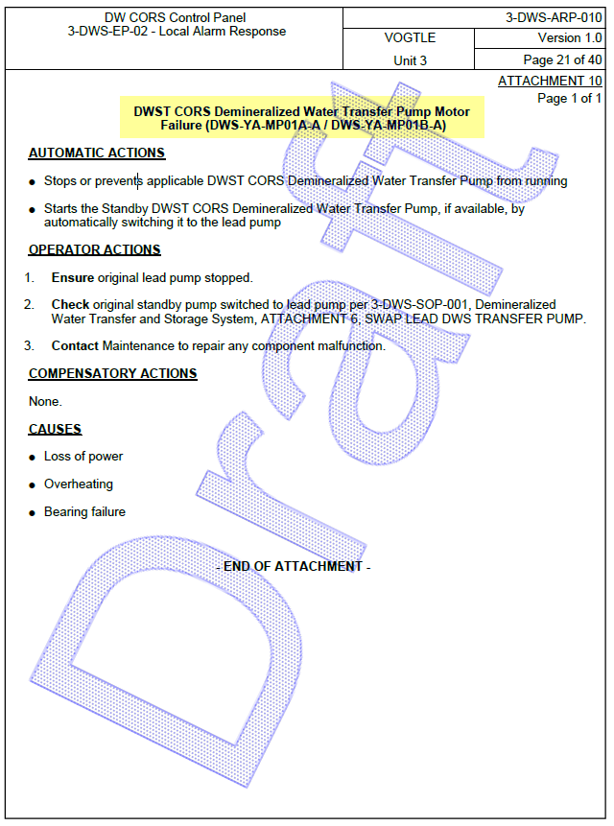

Changes/Additions to User Documentation:

N/A

