January 26, 2025

Applicability: All Plants

Internal Release Information:

B2026-007 PROMS Security - don't error when add a user to a group but no group selected/
C2026-004 – Add a messagebox when create group

Don’t error out when trying to add a user to a group with the << button but no user is selected.

Also, add a message box detailing a group has been added when adding a group.

- [Check this box if a sql query or a data fix applies to this update].

Generic External Release:
Adding some messaging to the PROMS Security tool.

Plant Specific Information for Release Letter:
None

Testing Requirements:
- Use any plants data as an admin user
- Go to V->Administration->Security->Manage Security
- Add a group
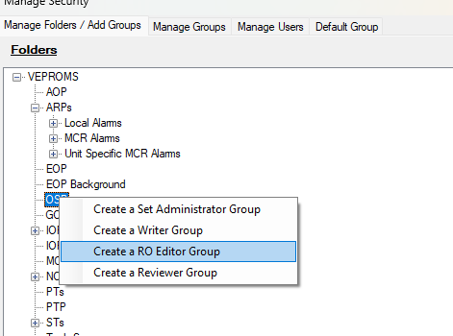
- This should produce a message box:
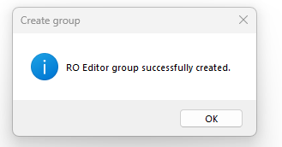

- Go to the Manage Groups tab
- Add a User to the Group with the << button
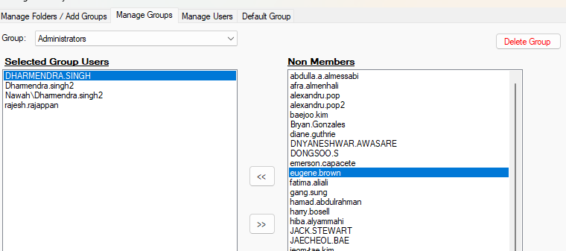
- After the User is added, click the << button again (no user should be selected in the Non-Members list.
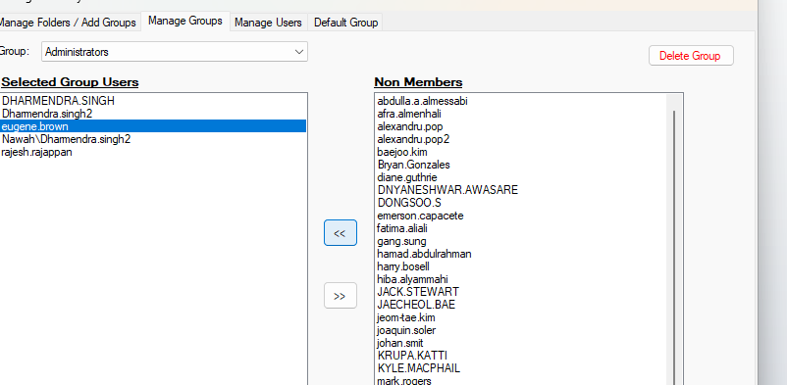
- When this is done, nothing should happen / i.e. it should not error.

Changes/Additions to PROMS Manual and Training Videos:
[Do not use this section – for MRV/DMJ use]
- CSM submitted for PROMS User Manual: ____________.
- CSM submitted for training videos: ____________.

