March 13, 2024

Applicability: Vogtle Units 3 & 4 EOPs

Internal Data Fixes: N/A

Internal Release:
F2024-043
Corrected box around second level continuous action sub-step.

Generic External Release:
N/A

Plant Specific Information for Release Letter:

N/A format under development and currently not used by the customer

Testing Requirements:
Use Vogtle data
- Update formats
- Print procedure FR-Z.4
- Verify the box around step 4.a.RNO.2 looks like the sample below

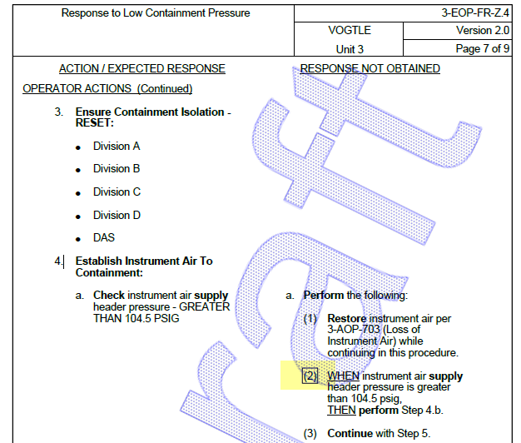

Changes/Additions to User Documentation:

N/A

