May 5, 2026

Applicability: GEN

Internal Release Information:

C2026-014 Set Changebar date with multi-unit

This came out of working on "C2026-009 Reset Change Bars to Date of Last Approval" -- multi-unit was never fully considered with Change Bars.
As such, there can be different Change Bar dates set per unit vs overall ---- overall is what will show in the UI vs per unit is what will be used while printing each unit.
The current "Set Change Bar to date _____" option only sets the overall Change Bar Date. This should be changed. Should it set both the overall and the dates for all units?

- [Check this box if a sql query or a data fix applies to this update].

Generic External Release:
Change to the Set ChangeBar date option to set for all units when the overall is manually set.

Plant Specific Information for Release Letter:
None

Testing Requirements:
- Use any data with multiple units
- Make a change to a procedure
- Use the “Showing Change Bars Starting ___ ” – set a date or click Today then click ok.
- Check the Change Bar History (which can be viewed on the Step Properties -> History Tab)
Make sure it has notes both for the overall changebar and for each unit that had been previously approved
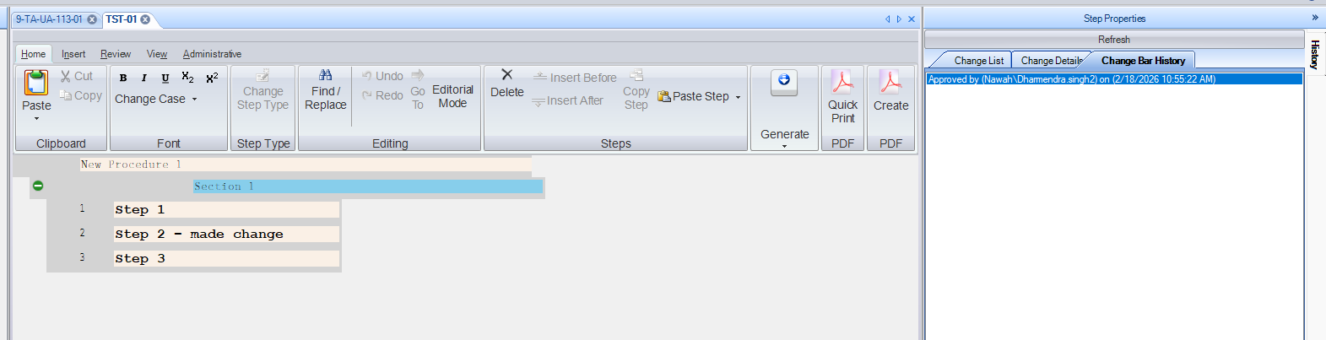
- The Steps should show/not show the Changebar in the UI appropriately
- Printing each unit should show/not show the Changebar appropriately.

Changes/Additions to PROMS Manual and Training Videos:
[Do not use this section – for MRV/DMJ use]
- CSM submitted for PROMS User Manual: ____________.
- CSM submitted for training videos: ____________.

