September 25, 2025

Applicability: GEN

Internal Release Information:

C2015-028 Add Editorial Mode to PROMS Step Editor

- [Check this box if a sql query or a data fix applies to this update].

Generic External Release:
Added an Editorial Mode to PROMS Step Editor. While in editorial mode, changes made will not produce change bars. If a change bar previously existed, then it will remain.

Plant Specific Information for Release Letter:
Calvert Cliffs - Added an Editorial Mode to PROMS Step Editor. While in editorial mode, changes made will not produce change bars. If a change bar previously existed, then it will remain. This will work in addition to your format flag to prompt / allow for change ids: While Editorial Mode is active, it will behave as though no change id or “EC” was entered in the changed field. Once it is deactivated, it would use the entered Change id. This will allow a user to easily enter a number of changes to a procedure that would require a change-id/change-bar but exclude a particular change that they did not want to mark as a change (perhaps a misspelling or typo).

Testing Requirements:
- Use Any DB (Except Calvert Cliffs, D.C. Cook, Fargo, or Vogtle)
- “Editorial Mode” should be added to both the PROMS ribbon and the Context Menu when clicking inside a step as long as the user is something other than a Reviewer. Reviewer Only users will not get the option for Editorial Mode.
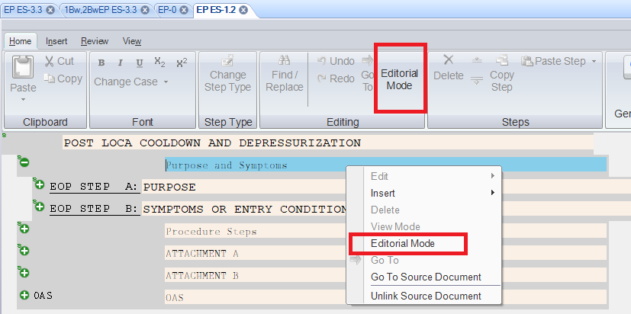
- Selecting either will toggle “Editorial Mode” On/Off.
- Toggling the Mode will change for all currently open tabs. And opening a new tab with open with Editorial Mode toggled in the previous state.
- While Editorial Mode is active,
  - If a step already contained a change-bar, it would continue to do so.
  - If a step did not contain a change-bar, and changes were made while in editorial mode, then a change-bar should not be added.
  - The above also includes any changes made by the spell checker while in “Editorial Mode”
  - The currently selected step field shall have a light green background instead of sky blue.
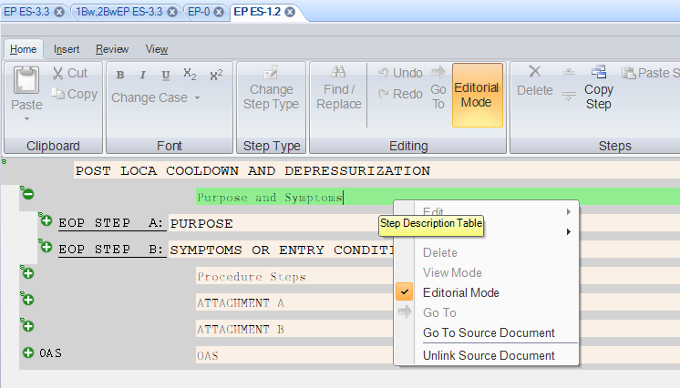
- Change bars in linked background steps should now show based on the linked parent step.
(This should be the case now despite the reason for the change bar not showing (Editorial Mode vs EditoralSpellCheck vs Calvert Cliffs ChangeID format flag)) – test this for “Editorial Mode”
- Reopen PROMS and open the same procedure as previously
- Special testing for Fargo / Vogtle (use Farley) - These contain a format flag (EditoralSpellCheck) that disables Change bars for changes made via the Spell Checker. Need to test that this still works and was not impacted by the new “Editorial Mode” Spell Checker should behave the same both if in “Editorial Mode” and if this flag is set in the format file.
- Change bars in linked background steps should now show based on the linked parent step.
(This should be the case now despite the reason for the change bar not showing (Editorial Mode vs EditoralSpellCheck vs Calvert Cliffs ChangeID format flag)) – test this for EditorSpellCheck Flag
- Special testing for Calvert Cliffs (Calvert Cliffs has special formatting flags where it asks for a Change ID – if no id is given or EC is entered, then it will not get a change bar. When printing with change bars, this ID will print next to the change bar)
- Need to test that for Calvert Cliffs, this still works when Editorial Mode is not used.
- For CC, when “Editorial Mode” is used, it acts as an override resulting in no change bar despite having an ID in the Change bar tab.
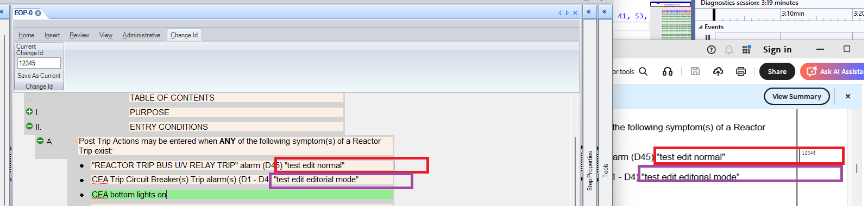
- Change bars in linked background steps should now show based on the linked parent step.
(This should be the case now despite the reason for the change bar not showing (Editorial Mode vs EditoralSpellCheck vs Calvert Cliffs ChangeID format flag)) – test this for Calvert Cliffs ChangeID format flag

Changes/Additions to PROMS Manual and Training Videos:
[Do not use this section – for MRV/DMJ use]
- CSM submitted for PROMS User Manual: ____________.
- CSM submitted for training videos: ____________.

