10/8/2024 (From 10/3/2024)

Applicability: All plants

Internal Release Information:
C2020-049 Add the ability for PROMS to remember the procedure tabs that were open when you closed PROMS.
Added code to skip saving PROMS Edit widows' tabs state when not necessary (10/8/2024).

- [Check this box if a sql query or a data fix applies to this update].

Generic External Release: PROMS now remembers which procedures are open in the PROMS edit window and reopen them after the application is closed and re-opened. PROMS remembers the open procedures for every user.

Plant Specific Information for Release Letter: N/A

Testing Requirements:
- Use DB VEPROMS_PROMS_MANUAL.
- Open more than one procedure in the PROMS editor.
- Note which procedures you opened and the order they were opened.
- Close the PROMS application and then reopen it.
- Check the tabs to make sure that the same procedures are open and the order that they were originally open in.
- Close one procedure and open two or more other ones.
- Close the PROMS application and then reopen it.
- Check the tabs to make sure that the same procedures are open and the order that they were open in.
- Close the PROMS application and start the application under another user.
- You should see that there are no procedures open in the editor.
- Under the new user step through the above steps used for the first user.
- When finished testing the second user close the application and reopen it under the first user.
- You should see the editor in the same state you had left it when you tested with the first user.

PROMS screen shot with editor tabs highlighted.
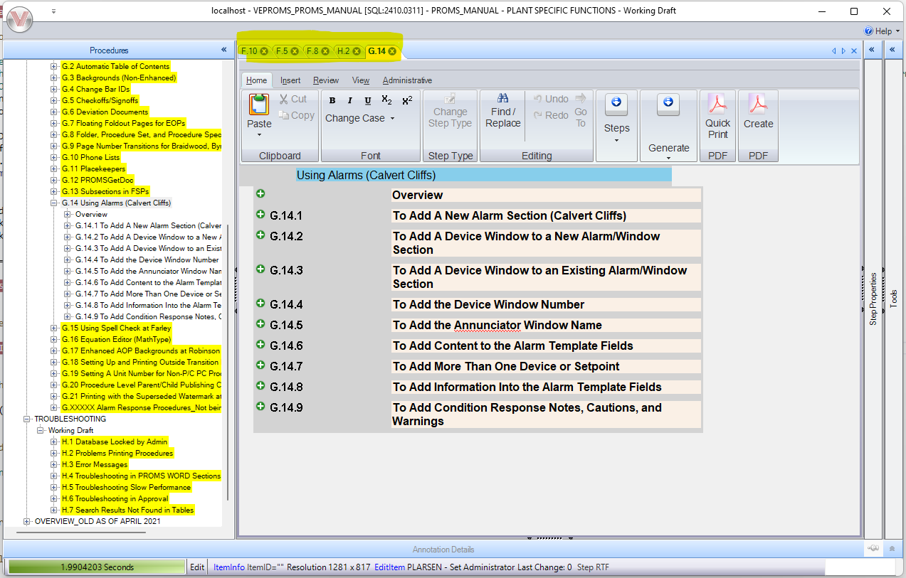

Changes/Additions to PROMS Manual and Training Videos:

- CSM submitted for PROMS User Manual: ____________.
- CSM submitted for training videos: ____________.

