9/12/2023

Applicability: C2023-015: Vogtle 3 & 4 Alarm pagination: paginate sub-steps

Internal Data Fixes: NA

Internal Release:

C2023-015: Vogtle 3 & 4 Alarm pagination: paginate sub-steps. This is currently only supported for Vogtle 3_4 alarm sections. This was implemented in a similar way to the preferred pagination setting for Supplemental Information. On the Step Properties/Tags panel, added a checkbox for ‘Substep Page Break’. If checked, the page break will occur on this substep. Note that this feature is available when the AlarmPagination flag is set on the docstyle for a section (docstyle) in the format file. If it is decided that this should become more widely available, this flag should be made unique, i.e. not tied to AlarmPagination that was added for Vogtle 3 & 4.

Generic External Release: NA

Plant Specific Information for Release Letter: NA Initial Work

Testing Performed:

See Testing Required.

Testing Requirements:

Using the Vogtle 3_4 sql database:
£ Bring up BDS-ARP-001-008 in the editor (id 1404 can be used)
£ Print for Unit 3 and notice where page breaks are, i.e. break after step 3 and all of 4 fits on page
£ Select the 3rd bullet under step 4.a, ‘CLOSED (STOP, OFF, DISABLE, DIVERT), displaye the Step Properties/Tags tab, and check the ‘Substep Page Break’ checkbox under Pagination
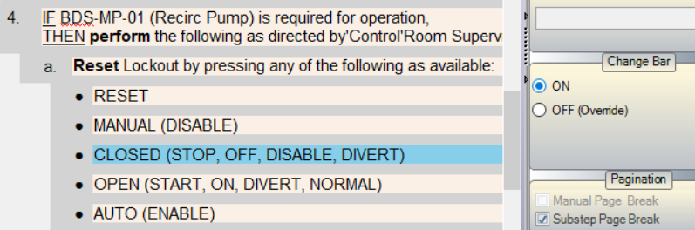

£ Print for Unit 3 and notice where page breaks are, i.e. now step 4 should break on the ‘CLOSED’ bullet.
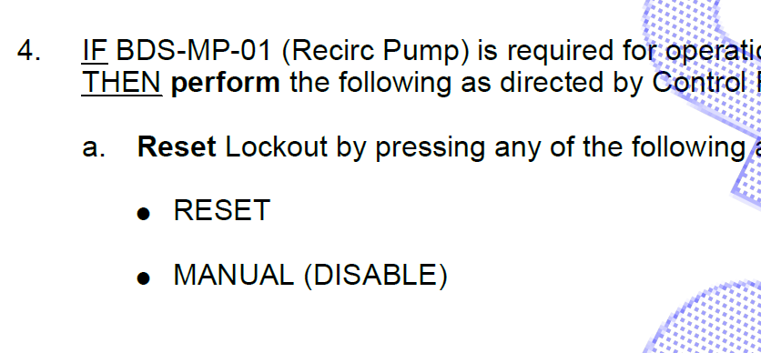
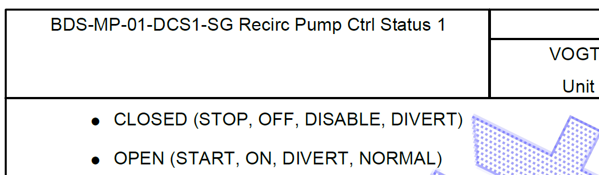
Changes/Additions to User Documentation: NA – if this becomes available for general use, then the Step Properties/Tags change should be added to User Documentation

