February 27, 2024

Applicability: Vogtle Units 3 & 4

Internal Data Fixes: N/A

Internal Release:
F2024-029
Add a bottom continue message in the Attachment – Step Editor section type in the Vogtle Alarms format.

Generic External Release:
N/A

Plant Specific Information for Release Letter:
Vogtle Units 3 & 4
For the Alarms format, the Attachment - Step Editor section type will now include a bottom continued message

Testing Requirements:
Use Vogtle data
- Update formats
- Print Local Alarm procedure VBS-ARP-013.
- Verify that Attachment sections that are more than one page long have a bottom continue message.

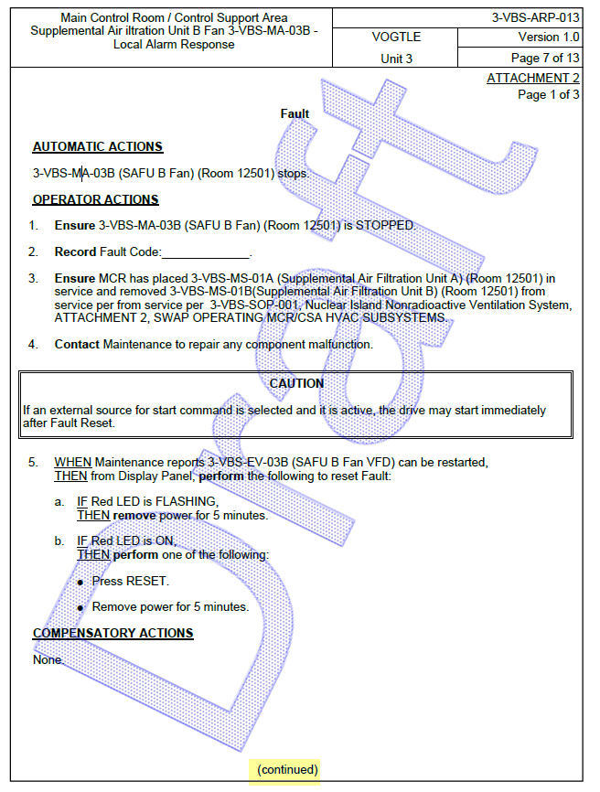

Changes/Additions to User Documentation:

N/A

