February 11, 2026

Applicability: All Plants

Internal Release Information:

C2026-009 Reset Change Bars to Date of Last Approval

Currently we have an option in the tree menu for "Showing Change Bars Starting" where a user can select "Today". Add an option to “Reset Change Bars to Date of Last Approval” to the "Showing Change Bars Starting" option in the tree view of a procedure. This would set the date / time for the change bars to the date / time of the last approval. If no approvals have been completed, this would clear the change bars date to show all changes since procedure creation.

- [Check this box if a sql query or a data fix applies to this update].

Generic External Release:
Added an option to “Reset Change Bars to Date of Last Approval” to the "Showing Change Bars Starting" option in the tree view of a procedure. This would set the date / time for the change bars to the date / time of the last approval. If no approvals have been completed, this would clear the change bars date to show all changes since procedure creation.

Plant Specific Information for Release Letter:
None

Testing Requirements:
- Use Any db (may need to use multiple different dbs or create certain test cases.
General Instructions:
- Click on the Tree View on a Procedure, and Select “Showing Change Bars Starting”
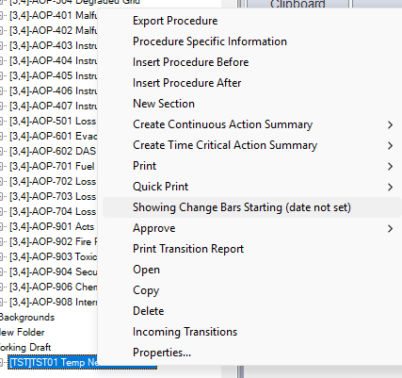
- Click on the Option “Reset Change Bar To Approved Date”
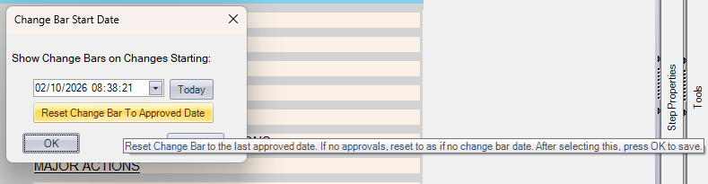

Test Case 1:
- Open (or create) a non-multi unit procedure with no approvals
- Make Changes to the procedure
- Then use the “Showing Change Bars Starting” to set the Change Bars to right Now
You will see:
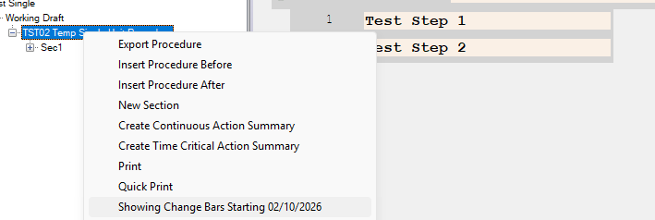
- Perform the General Instructions
- You will receive a prompt:
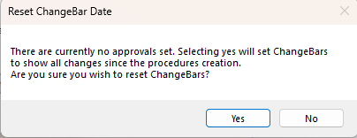
- Selecting No will perform no action
- Selecting yes will close the prompt and set the Change Bar back to no date set
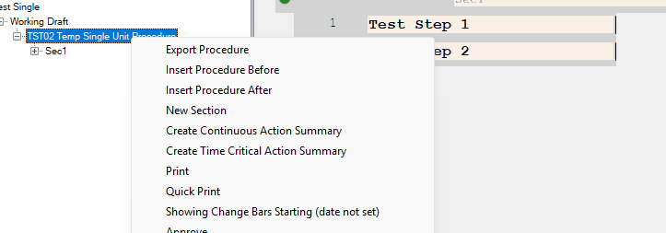

Test Case 2:
- Open (or create) a non-multi unit procedure with an approval
- Make Changes to the procedure
- Then use the “Showing Change Bars Starting” to set the Change Bars to right Now
You will see (in the treeview – Showing Change Bars Starting__[Today’s Date]___:
- Perform the General Instructions
- You will receive a prompt:
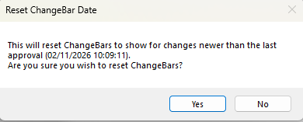
- Selecting No will perform no action
- Selecting yes will close the prompt and set the Change Bar back to the date specified in the prompt.
- This can be checked via the Viewer / Tree View and by Printing with Show Change Bars On.

Test Case 3:
- Open (or create) a multi-unit procedure with no approvals
- Make Changes to the procedure
- Then use the “Showing Change Bars Starting” to set the Change Bars to right Now
You will see (in the treeview – Showing Change Bars Starting__[Today’s Date]___:
- Perform the General Instructions
- You will be prompted to ask if You are sure -: “There are currently no approvals set. Selecting yes will set ChangeBars to show all changes since the procedure creation…”
- Selecting No will perform no action
- Selecting yes will close the prompt and set the Change Bar back to no date set

Test Case 4:
- Open (or create) a multi-unit procedure with approvals for multiple units. You may need to make changes between the different unit approvals in order to test the printing of the multi-unit.
- Make Changes to the procedure
- Then use the “Showing Change Bars Starting” to set the Change Bars to right Now
You will see (in the treeview – Showing Change Bars Starting__[Today’s Date]___:
- Perform the General Instructions
- You will be prompted if sure – given details about how it will update the Change Bars. Overall will be updated to the most recent date. For example:
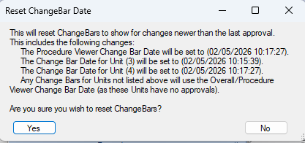
- Selecting No or closing out with the X will perform no action
- Selecting yes will close the prompt and set the Change Bar back to the date/times provided in the prompt.
- The overall can be checked via the Viewer / Tree View. The individual units will need tested via printing with change bars on and the appropriate change bars showing based on when changes were made.

Test Case 5:
- Open (or create) a multi-unit procedure with an approval for one unit
- Make Changes to the procedure
- Then use the “Showing Change Bars Starting” to set the Change Bars to right Now
You will see (in the treeview – Showing Change Bars Starting__[Today’s Date]___:
- Perform the General Instructions
- You will be prompted to ask if You are sure -: “This will reset ChangeBars to show for changes newer than the last approval. … This includes the following changes: …”
- Selecting No will perform no action
- Selecting yes will close the prompt and set the Change Bar back to the date/times provided in the prompt. Any Units that did not have any approvals will have ChangeBars set to show changes since the overall (procedure viewer changebar setting.
- The overall can be checked via the Viewer / Tree View. The individual units will need tested via printing with change bars on and the appropriate change bars showing based on when changes were made.

Changes/Additions to PROMS Manual and Training Videos:
[Do not use this section – for MRV/DMJ use]
- CSM submitted for PROMS User Manual: ____________.
- CSM submitted for training videos: ____________.

