February 12, 2026

Applicability: Vogtle Units 3&4

Internal Release Information:
F2064-008
Turned off pagination flags that caused bad pagination in the background steps

- [Check this box if a sql query or a data fix applies to this update].

Generic External Release:
N/A

Plant Specific Information for Release Letter:
N/A – format under development

Testing Requirements:
Use Vogtle Units 3 & 4 Data
- Print the background for AOP-302
- Look at Attachment 1 Step 1 and verify that sub-step 2 and the paragraph below it are on the first page of that background step

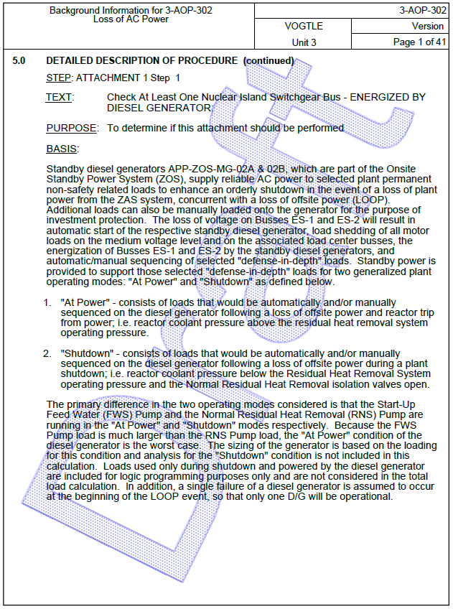

Changes/Additions to PROMS Manual and Training Videos:
[Do not use this section – for MRV/DMJ use]
- CSM submitted for PROMS User Manual: ____________.
- CSM submitted for training videos: ____________.

