September 26, 2025

Applicability: GEN

Internal Release Information:

B2025-048 Problem with Printing CAS Steps

Issue found where certain CAS sections are skipped when “Print Section Number and Title” is selected for a section with CAS steps.

Found on Vogtle when Lydia was doing baselines (prior to release):

When an Operator Action section with CAS steps is followed by one Attachment Step Editor section also containing CAS steps PROMs is getting confused and only printing the CAS steps from the 1st Attachment (EOP-ES-1.1). However, if there is an additional Attachment between the Operator Action Section and the Attachment containing the CAS steps then all the CAS steps print (EOP-E-1)

- [Check this box if a sql query or a data fix applies to this update].

Generic External Release:
N/A – Found Internally. Unlikely to occur for customer.

Plant Specific Information for Release Letter:
Vogtle - When an Operator Action section with CAS steps was followed by one Attachment Step Editor section also containing CAS steps PROMs was only printing the CAS steps from the 1st Attachment. It will now print the Operator Action CAS steps appropriately.

Testing Requirements:
- Use Vogtle data at:
V:\temp\VEPROMS_Vogtle_3_4_backup_2025_09_25_092012_5736512.7z
- Open EOP-ES-1.1
- Generate a CAS Summary
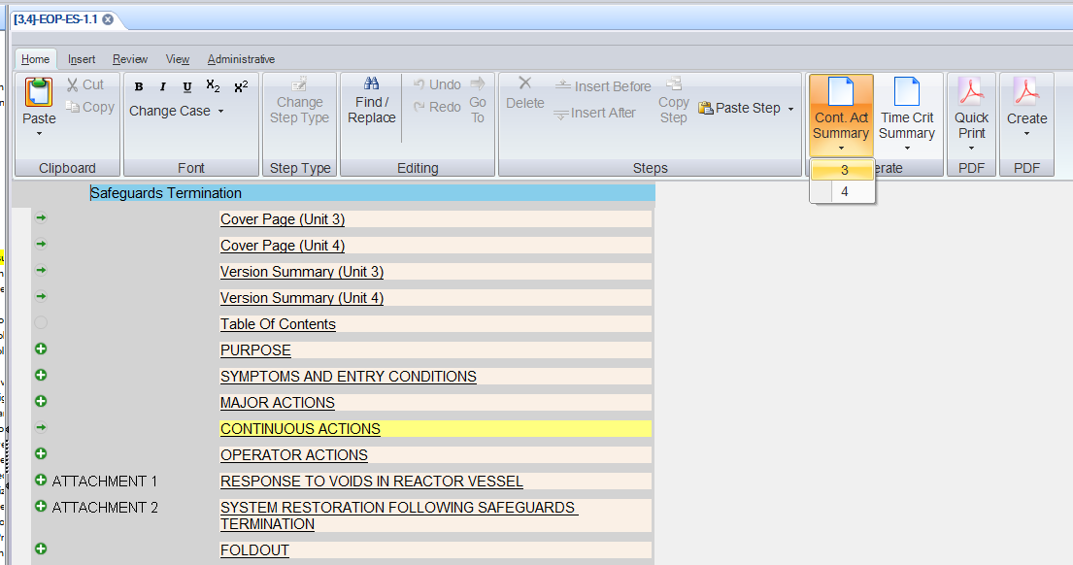
- PROMS should print appropriate CAS sections / steps (previously, it was not printing Operator Actions or any of its CAS steps)

Changes/Additions to PROMS Manual and Training Videos:
[Do not use this section – for MRV/DMJ use]
- CSM submitted for PROMS User Manual: ____________.
- CSM submitted for training videos: ____________.

