February 2, 2026

Applicability: All Plants

Internal Release Information:

C2026-062 When Search clicked - Load the Incoming transitions for the Active Procedure

Upgrade - For the Incoming Transitions tab on the Search panel.
If the user didn't previously run the Incoming Transition function for the Procedure Tree, or they tried to delete a procedure that has references to it, the only option the user has is to Load a previously saved result.

For cases like this we should: Utilize the Search button on the Incoming Transitions panel to load incoming transitions for the current active procedure.

- [Check this box if a sql query or a data fix applies to this update].

Generic External Release:
Added Search button to the Incoming Transitions Panel. This will load the incoming transitions for the procedure in the current active window.

Plant Specific Information for Release Letter:
None

Testing Requirements:
- Use any plants data
- Open a procedure, go to the Incoming transitions tab and click Search
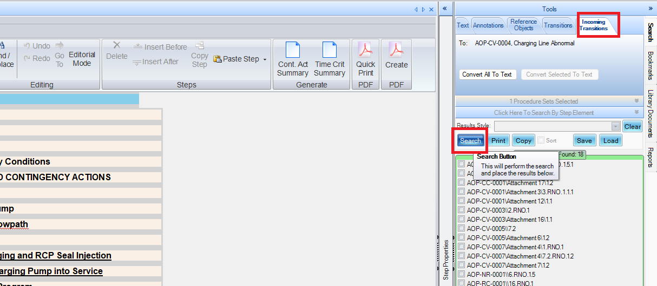
- If you are on the overall procedure, it will load the incoming transitions for the active procedure
- If you are on a specific step, it will prompt if the user wants to load the incoming transitions for the procedure or for the step.
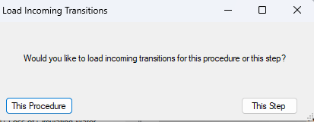
--No changes were made to the incoming transitions logic, so this should behave exactly the same as selecting “Incoming transitions” in the tree view for a particular step or procedure.
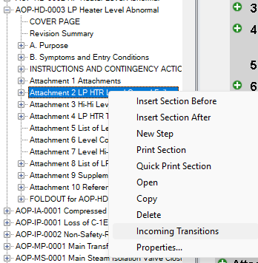

- If you close all the open procedures then click the search button, it will give the message:
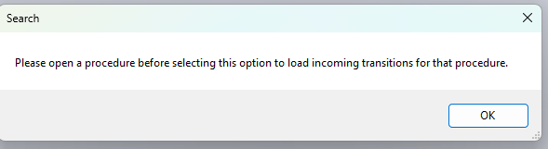
- On the Incoming Transitions tab, do not allow the Style of the Search Results to be changed (the different styles do not make sense for incoming transitions)
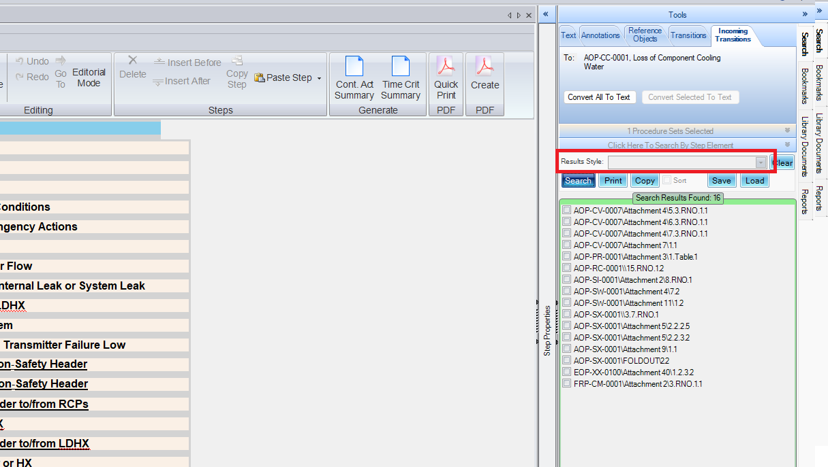

Changes/Additions to PROMS Manual and Training Videos:
[Do not use this section – for MRV/DMJ use]
- CSM submitted for PROMS User Manual: ____________.
- CSM submitted for training videos: ____________.

