August 11, 2025

Applicability: All plants

Internal Release Information:
B2025-038 Copy a step from one screen to another.
When coping a step and the text from one screen to another the text in the copied step does not come over.
SQL updates included.

Generic External Release:
Coping a step and the text from one screen to another now works.

Plant Specific Information for Release Letter:
N/A

Testing Requirements:
- USE DB VEPROMS_BeaverValley
- Open procedure EOP/Unit 1/Working Draft/ES-0.2 Natural Circulation Cooldown.
- Open procedure EOP/Unit 2/Working Draft/ES-0.2 Natural Circulation Cooldown.
- Drag Unit 2 ES-0.2 Natural Circulation Cooldown to open it in the right screen. Unit 1 should be in the left screen.
- Add a new step under one of the categories (ex: PURPOSE, MAJOR ACTION CATEGORIES etc.) in the left screen.
- Add text to the new step.
- Do not move out of the step
- Click copy step.
- In the right screen place the curser in a step.
- Click on Paste step and select one of the three options to paste the copied step.
- Retry above steps on other procedures. One from EOP unit 1 and EOP unit 2.

Images:

Two screens

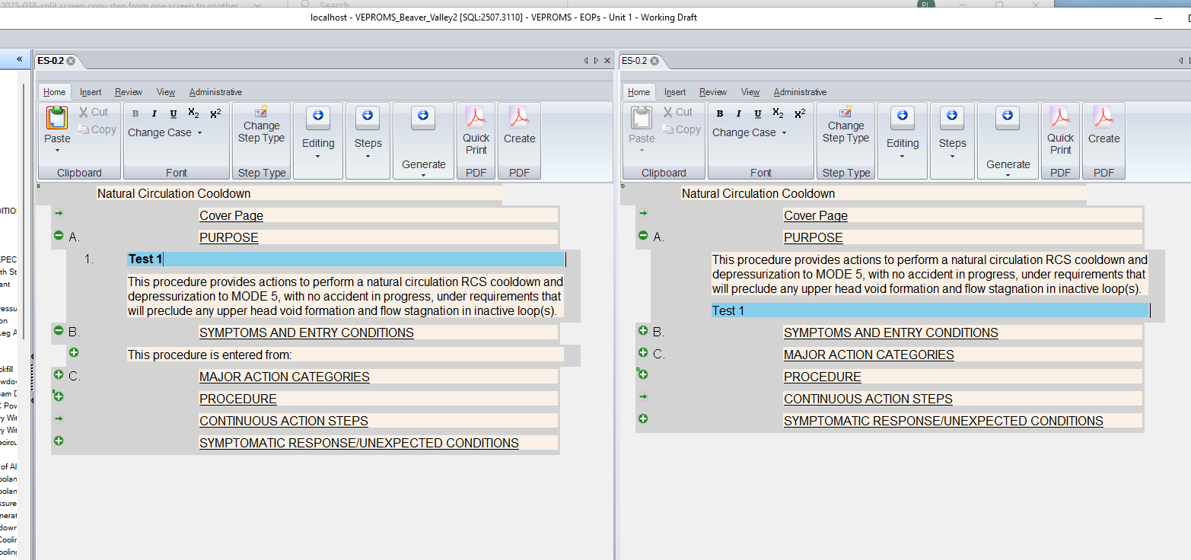
Changes/Additions to PROMS Manual and Training Videos:
[Do not use this section – for MRV/DMJ use]
- CSM submitted for PROMS User Manual: ____________.
- CSM submitted for training videos: ____________.

