September 11, 2025

Applicability: GEN

Internal Release Information:
C2025-034 Upgrade PROMS to 64 bits

Upgrade PROMS to take advantage of extra memory allowed using 64 bits.

- [Check this box if a sql query or a data fix applies to this update].

Generic External Release:
Upgrade PROMS to take advantage of extra memory allowed using 64 bits.

Plant Specific Information for Release Letter:
N/A

Testing Requirements:
- Determine that PROMS is running as 64-bit: To determine if PROMS is running in 32 bit or 64-bit can run task manager while PROMS is running, go to details, and add columns as necessary:
x86=32 bit, x64 = 64 bit
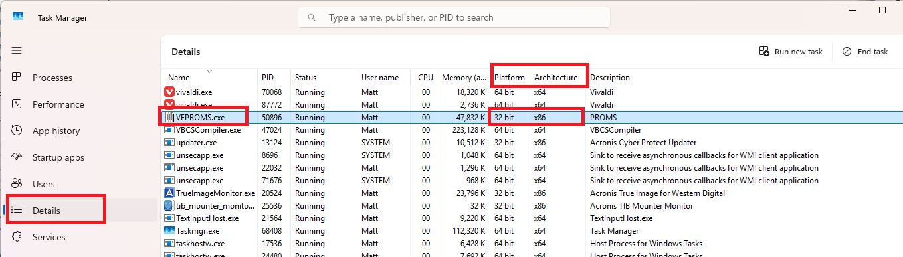

- Test EDraw: Open a Word Section in PROMS
- Test VlnStatus 64 bit: Run a RO Complete Report
- Test VlnStatus 32 bit still works: Open RO Editor from PROMS and export an RO.FST

Changes/Additions to PROMS Manual and Training Videos:
[Do not use this section – for MRV/DMJ use]
- CSM submitted for PROMS User Manual: ____________.
- CSM submitted for training videos: ____________.

