December 26, 2025

Applicability: All plants

Internal Release Information:
C2025-048 Add ability to add Symbols in RO Editor.

SQL updates included.

Generic External Release:
The ability has been added to the RO Editor to add Symbols in RO Editor fields. These symbols will show up in PROMS in the RO

Plant Specific Information for Release Letter:
N/A

Testing Requirements:
This testing outline will have the tester create an RO with the RO editor and place symbols in the fields. Save the RO and Create an RO.FST. The tester will also Create a Setpoint RO save and test the Zoom function. Then after updating the ROs in PROMS the tester will add ROs then have the symbols into a step.

- USE ANY DB
- Open RO Editor from Step Ribbon.
- Right click on “Reference Objects” and select “Group” to create a new database.
- Enter “Symbols Test” in the Group field.
- Enter data in the dialog that appears below.

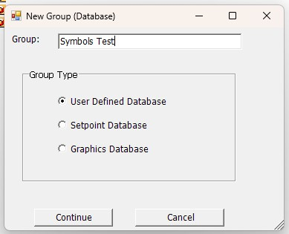

- Click Continue.

- Fill in the form as shown below.

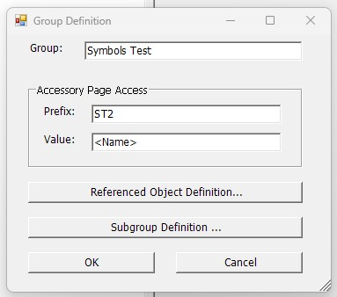

- Click “Reference Object Definition” and fill in the form as shown below and click OK.

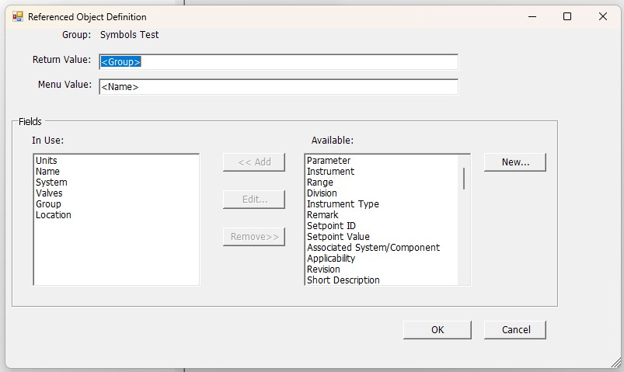

- Click OK.

- Now click “Subgroup Definition”. Enter the data as displayed below.

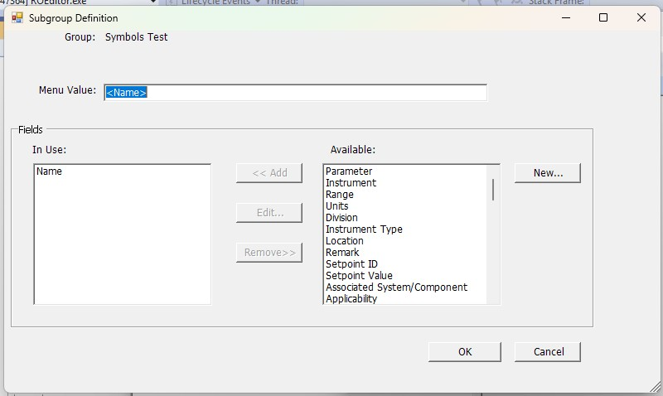

- Click OK.

- Click OK.

- Click Continue.

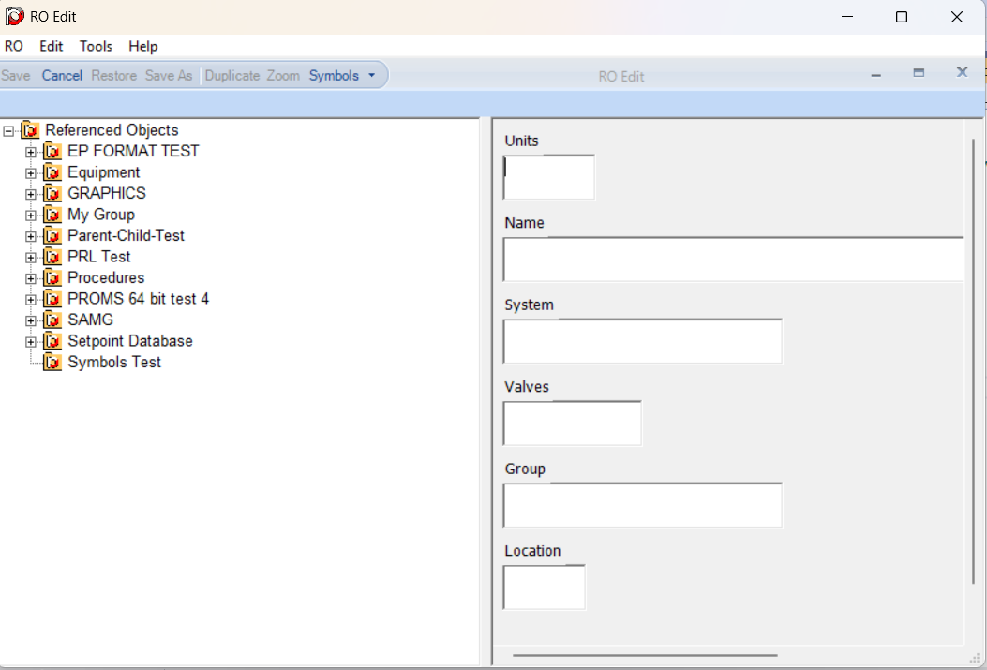

- Right click the new database “Symbols Test” and select new Reference Object. Fill in the form. In each of the fields add a Symbol at the end of the text (Click Symbols button and select a symbol. The symbol will be place where the cursor is.) Then click the Save button.
- You will not be able to add a symbol in the Name field on account that it is the ID field. If you can then that is a bug.
- Make sure that all the symbols appear and no Unicode information does.
- In RO Editor click Tools/Create RO.FST.
- Test setpoint symbols.

- Open RO Editor
- Under the Setpoint Database create a new Group called “Symbols Test”.
- To that group add a new "Reference Object".
- Fill in the fields.
- For the Setpoint Value field click either "Table" or "XY_PLOT" and add text into this field.
- Add a symbol in every field.
- You will not be able to add a symbol in the Setpoint ID field on account that it is the ID field. If you can then that is a bug.
- Put the cursor in the Setpoint Value field and click the "Zoom" button.
- Verify that the text and symbol appear in the Zoom popup.
- Save the new RO and make sure the symbols are saved and no Unicode information appears.
- Then click Create RO.FST

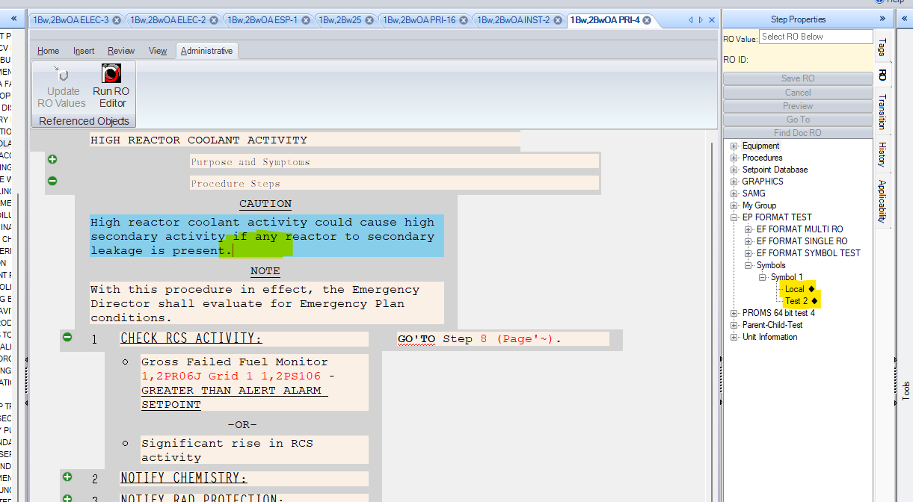

- Open PROMS. In the Administration Tab on the Step Ribbon click Update RO Values. Open a procedure that has Procedure Steps. Select a step. Open Step Properties and click the RO tab. Open “Symbols Test” and add the RO you previously added in RO Editor.”

Above is an example of what you might see in PROMS. Your test will look different. Add the test RO into one of the Steps.

- Make sure that the symbols appear in the RO tree and in the step. You should not see any Unicode information.
- Test to see that symbols cannot be added to the ID field but can be added to all other fields.
- Open RO Editor. Create a new RO under a Set Point group.

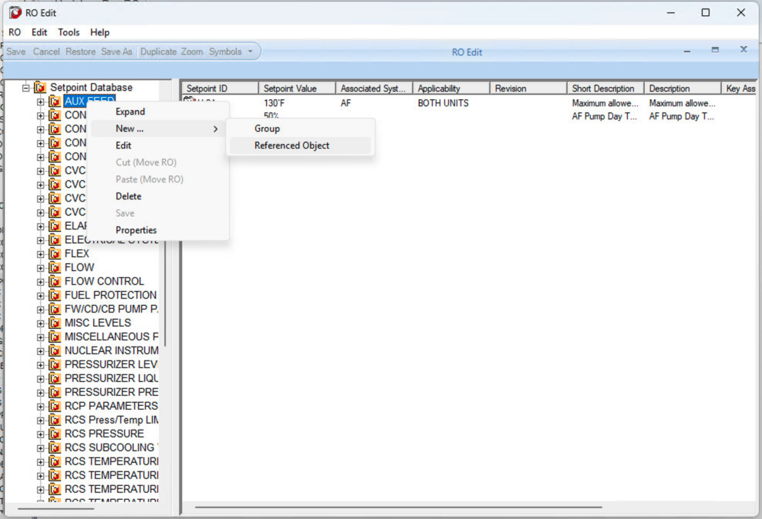

- Create a new RO.

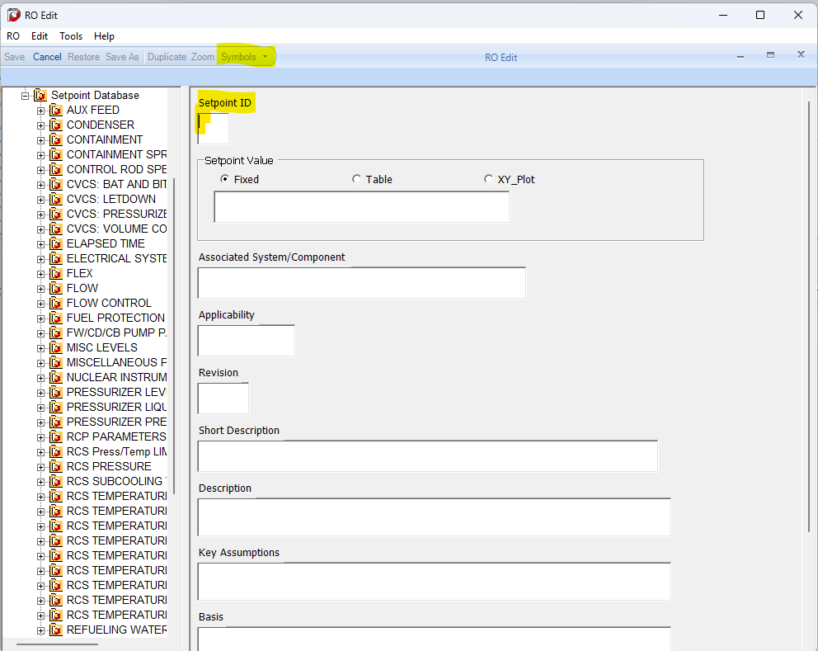

- You will test the enabling and disabling of the Symbols button. Notice in the above screen shot that the Symbols button is disabled when the cursor is in the Setpoint ID field. The Symbols button should be disabled in the RO ID field.
- Now click into another field. The Symbols button will now be enabled. Click back and forth between the Setpoint ID field and other fields to make sure the Symbols button enables and disables as described.

- Test parent child relationship in RO Editor.
- Find an RO that contains a parent child relationship.
- Create a new RO from the RO type.
- Add values to each field along with symbols.
- For the parent child relationship add values to each field. Make sure all parent child fields have different values and symbols.
- Save the new RO and review the saved RO.
- Report any anomalies.

Copy symbol test.

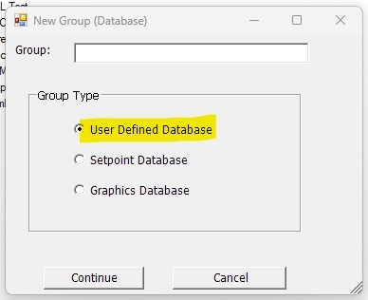

- Copy text and symbol from an RO field. (Use ctrl-C)
- In RO Editor right click Reference Objects element in the left tree and select group.
- Click in the group field and paste using ctrl-V.
- A popup should appear telling the user that you cannot paste a symbol in this field. The popup should show what is contained in the clipboard.

Changes/Additions to PROMS Manual and Training Videos:
[Do not use this section – for MRV/DMJ use]
- CSM submitted for PROMS User Manual: ____________.
- CSM submitted for training videos: ____________.

