February 14, 2025

Applicability: All Plants

Internal Release Information:
C2024-038 PROMS – Summary of Changes report generation enhancements

This is an upgrade item to add a method to exclude annotations and a way run the summary of changes report from a specific date.

- [Check this box if a sql query or a data fix applies to this update].

Generic External Release:
Upgrade to the Summary of Changes report generation to add a method to exclude annotations from the report as well as a method to run the report to view changes that have occurred since a specific date.

Plant Specific Information for Release Letter:
None

Testing Requirements:
- Use any plants data that has history. (May need to try several different plants to find specific examples – will be mentioned below)
- On a procedure, go to the Step Properties -> History -> Change List
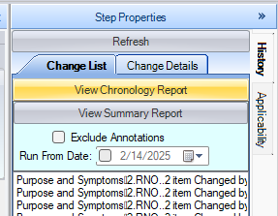
- (negative test) – Running “View Summary Report” without selecting either of the new options, report should behave exactly as it did before options were added.
- Running “View Summary Report” with selecting “Exclude Annotations” should produce the Summary Report but not include any items that were annotations in the PDF.
- Running “View Summary Report” with a date selected should limit the output as described below:
- If the first audit record for an item occurs after the date entered then it will show all the audit items for that date (because the item was added after the date and thus has been changed).
Example (from Braidwood – Rev 4 EOP Master – 1Bw, 2BwEP ES-0.0): If run for date: 1/1/1998
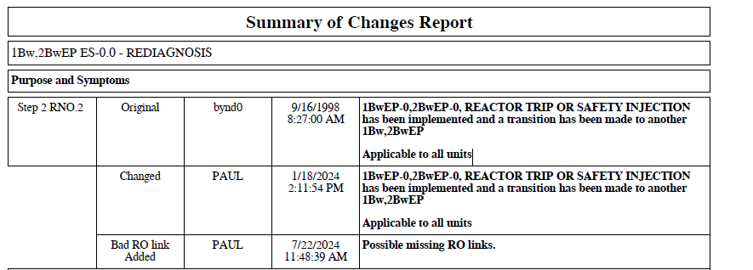
In this case would show these particular items exactly as if the report was not run for a date.
- If first audit record for an item occurs before the date entered and text currently matches what it was on the date entered then no items will show.
From the example above, if run for date: 1/1/2000, the items above would not show since the text was:
“1BwEP-0,2BwEP-0, REACTOR TRIP OR SAFETY INJECTION has been implemented and a transition has been made to another 1Bw,2BwEP

Applicable to all units”

Both as of 1/1/2000 and currently (after the last audit item)
- Exception to the above – If the latest audit record occurs after the date entered and is a deletion, then text comparison is ignored and
- The last item before the date will show with an As Of designation (if there is one)
- All Items newer than the date entered will show.

Example: Delete a step then run the Summary of changes as of yesterday and it should show the deletion.
- If first audit record for an item occurs before the date entered and text currently does not match what it was on the date entered then:
- The last item before the date will show with an As Of designation
- All Items newer than the date entered will show.

Example: from above run for 1/1/2000 – same procedure set, different step:
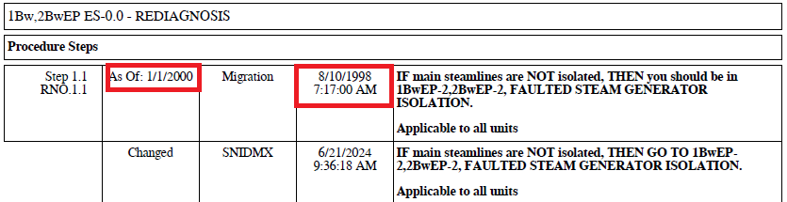

- If all audit records for a step occur earlier than the date entered, then no records will show for that step.

- If Exclude Annotations is not checked and a date to run report from is provided, then only annotations that occurred after the date provided will show.

Changes/Additions to PROMS Manual and Training Videos:
[Do not use this section – for MRV/DMJ use]
- CSM submitted for PROMS User Manual: ____________.
- CSM submitted for training videos: ____________.

