January 27, 2025

Applicability: All Plants

Internal Release Information:
B2025-010 PROMS – Change ID Issues

Removing the change id via backspaces in the change id box in the step properties panel can cause PROMS to crash. Also, it doesn’t always remove the change id properly. Changing this to instead of updating every time text changes in the box, adding a save button. Also, adding some null exception error handling.

- [Check this box if a sql query or a data fix applies to this update].

Generic External Release:
Updated the Change Id in the Step Properties -> Tags panel to add a Save button. This will improve the user experience and performance as it will no longer attempt to save every time a single digit in the box changes and also now only update if someone wishes to save the update.

Plant Specific Information for Release Letter:
This item was reported by Cody at Calvert Cliffs

Testing Requirements:
- Use Calvert Cliff’s data
- Go to STP U1, first procedure, Step 6.2.A.
- Enter something in the change id field when prompted.
- Click on the Change ID tab at the top of the edit window and expand the Step Properties panel to the Tags tab.
- Add some text to Step 6.2.A (or any step without an existing change bar). Move off the step then back on.
- Verify the change id is what you entered and what displays at the top of the window in the Change ID tab.
- In the Tags tab, start hitting the backspace.to remove the change ID.
- Previously PROMS would occasionally crash.
- Now utilize the new save button and test removal/changing of the change id.
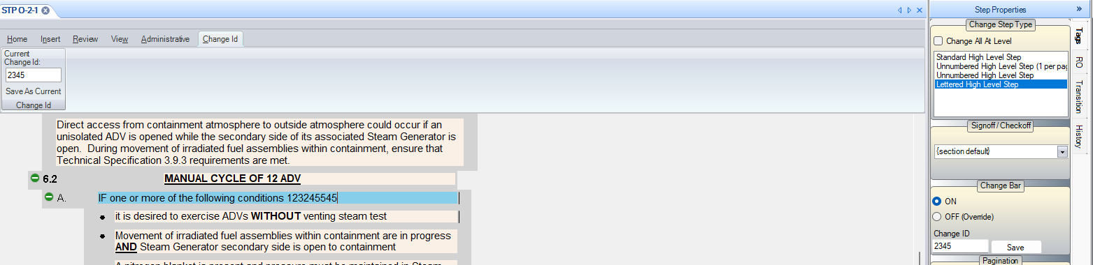
- (Negative Case) --- Do one test where you open data that does not have Change ids set in their Plant format data – for example: Braidwood
- In this case, in the Step Properties -> Tags Panel, you should not see the new “Save” button --- just as you also do not see the Change Id box

Changes/Additions to PROMS Manual and Training Videos:
[Do not use this section – for MRV/DMJ use]
- CSM submitted for PROMS User Manual: ____________.
- CSM submitted for training videos: ____________.

