Applicability: Ginna

Internal Data Fixes: N/A

Internal Release:
B2023-099
Restore the original calculation for finding he center point of the procedure and section END messages.

Generic External Release:

N/A

Plant Specific Information for Release Letter:

N/A – the customer does not have this issue with their current PROMS executable

Testing Requirements:
Use Ginna data
- Print SAG-5 in the Rev 2 SAMG Reference ONLY procedure set
- Verify the End of Section message (in the Diagnostic Section) is centered

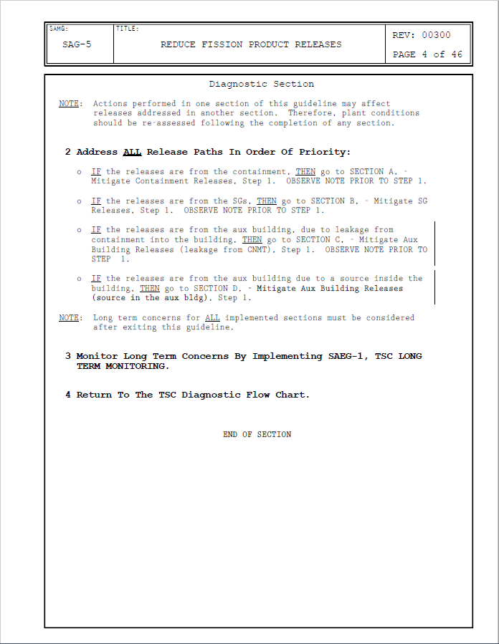

- Print ATT-6.0 in the EOP_AP ATTACHMENTS procedure set
- Verify the End message (page 2) is centered

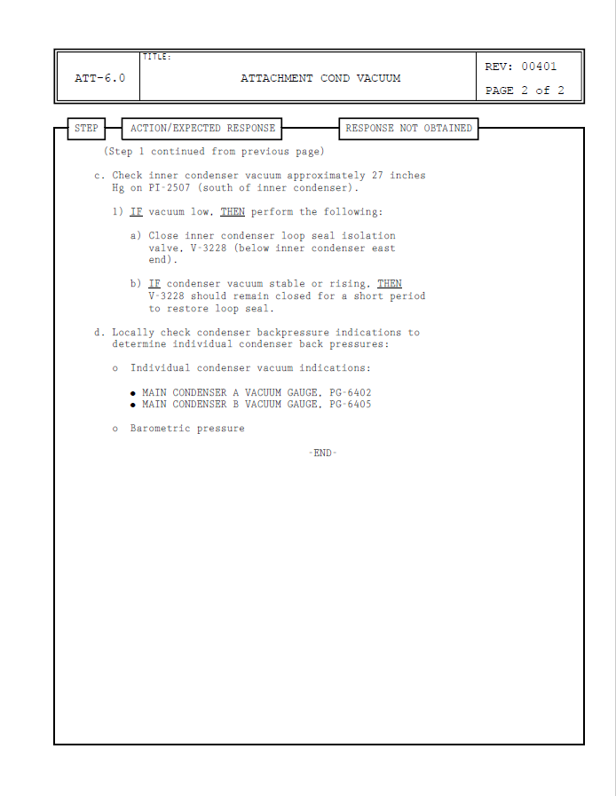

Changes/Additions to User Documentation:

N/A

