March 30, 2026

Applicability: All Plants

Internal Release Information:
B2026-035 fix RO Preview for X Y Plots
Fixed RO menu title to show symbols instead of Unicode. Fix PROMS RO tab RO preview to show symbols instead of Unicode.

- [Check this box if a sql query or a data fix applies to this update].

Generic External Release:
Symbols can now be added to RO X/Y Plots in the RO Editor. Symbols can only be added to X, Y, Z, and B rows.

Plant Specific Information for Release Letter:
N/A

Testing Requirements:
Test to verify that the symbols show up instead of Unicode in the menu title when updating an RO. Verify that when previewing an RO in PROMS that symbols will appear instead of unicodes.
- USE Callaway DB
- Open RO Editor
- Navigate to Injection Flow RO group and open RO with setpoint ID S328.
- Add a symbol in the Short Description field. Add the symbol in the middle of the text so it will show up in the preview.
- Save your change.
- Verify that the Menu Title contains symbols and not unicodes.
- Migrate the changes to PROMS.
- In PROMS navigate to the S328 setpoint in the RO tab in Step Properties and select it.
- Click the Preview button above.
- Verify that the symbol appears and not a Unicode.

Images:

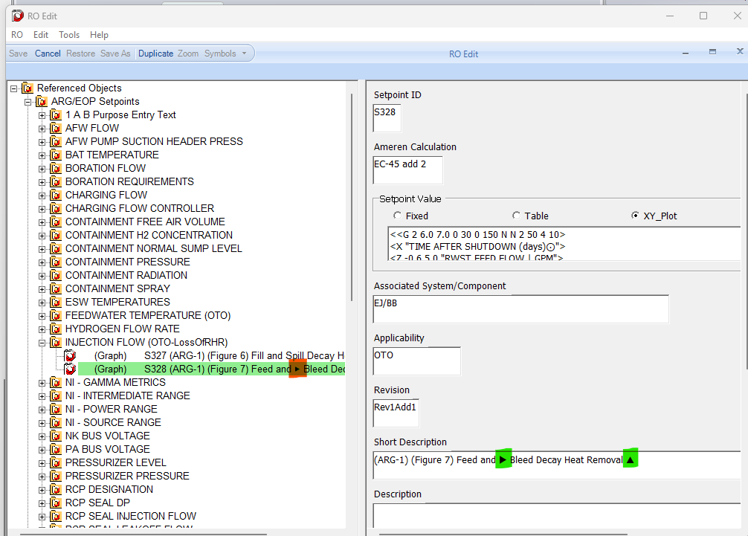

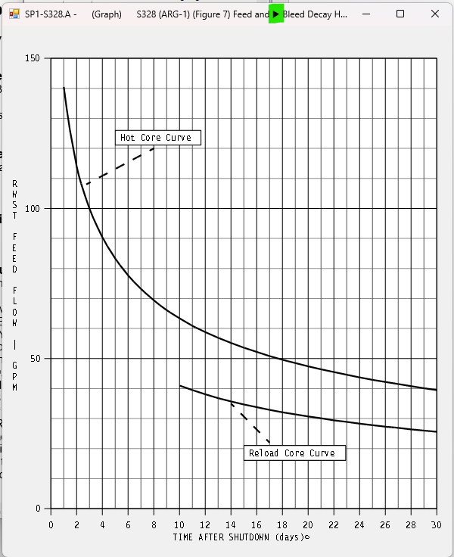

Changes/Additions to PROMS Manual and Training Videos:
[Do not use this section – for MRV/DMJ use]
- CSM submitted for PROMS User Manual: ____________.
- CSM submitted for training videos: ____________.

