1/24/2023

Applicability: B2024-001: Update of ROs with ‘<’ or ’>’ in table causes infinite loop on update when Updating from the ribbon or from Administrative tools.

Internal Data Fixes: NA

Internal Release:

B2024-001: Update of ROs with ‘<’ or ‘>’ when the RO is included in a table cell causes infinite loop when Updating from the ribbon or from Administrative tools. The infinite loop was occurring in the code that did the ROFST Load, i.e. ROFSTLookup.cs/Load.

Generic External Release:

Note the same information for ‘Generic External Release’ that was written for B2022-134 can be used. This fix was for the Update Ro if executed from ribbon or Admin Tools: Updating of Referenced Objects (ROs) when an RO has a ‘<’ or ‘>’ symbol and this RO is included in a table cell was crashing.

Plant Specific Information for Release Letter: NA

Testing Performed:

See Testing Required.

Testing Requirements:

Using the Ginna sql database and a local RO database (the test adds new ROs):

£ In Proms verify that the path to the RO database, from Working Draft Properties/Referenced Objects, is the local RO database

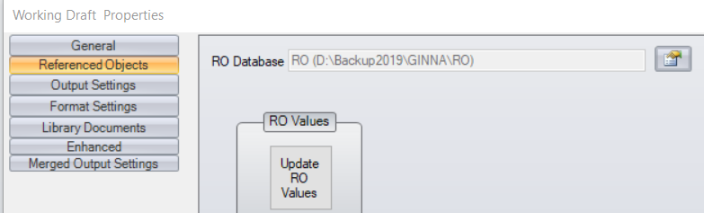

£ Bring up the RO Editor; add 2 new ROs, one containing ‘<’ and one ‘>’; Create RO.FST

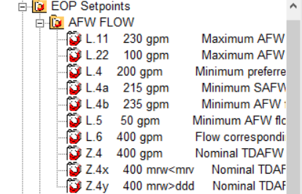

£ In Proms, update ROs, and then create a table with at least 2 cells. Insert these 2 ROs in two of the cells
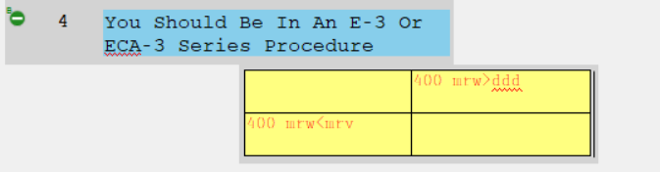
£ Leave the procedure open and go back to RO Editor, modify those ROs. Create RO.FST

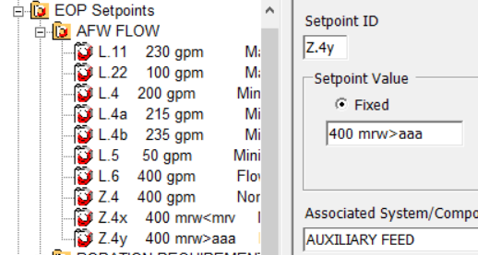

£ In Proms, using the ‘Administrative’ tab on the ribbon, Update ROs. Verify that this does not crash, with an ‘Out Of Memory’ error in error log.
£ Go back to the table that was created in the earlier step and verify that the 2 ROs have the change.

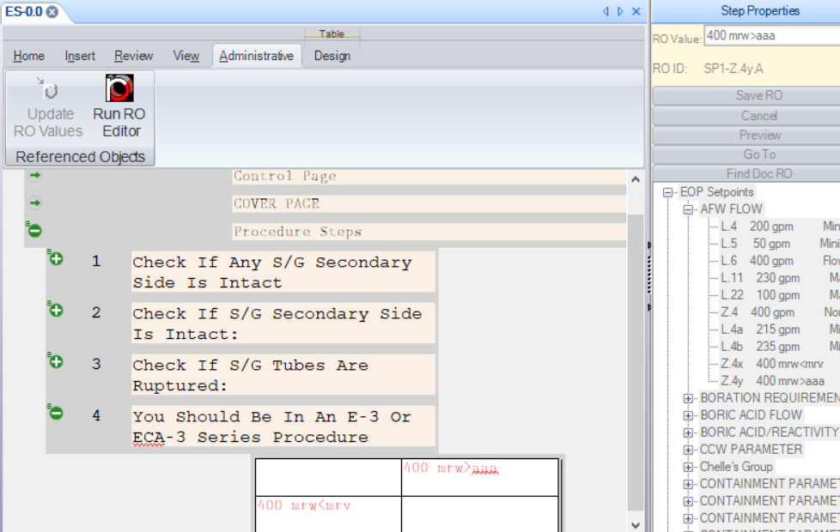

£ Leave the procedure open and go back to RO Editor, modify those ROs again. Create RO.FST

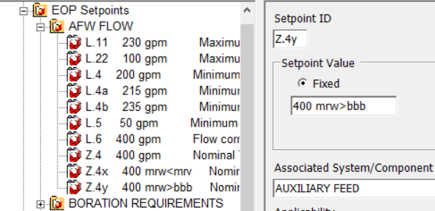

£ In Proms, using the V Button/Administration/Administrative Tools menu item, select ‘Links’, ‘Update RO Values’ and select the procedure set that the table is in. Select the ‘Process Links’ button to verify that the program doesn’t crash.
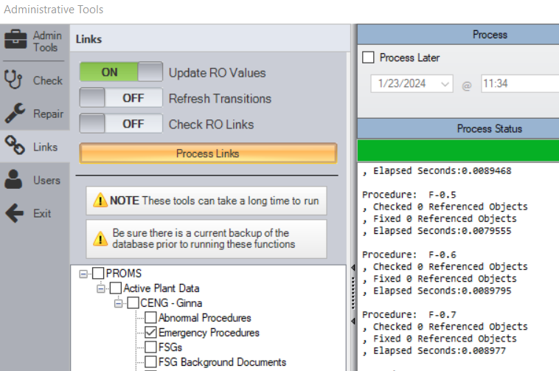

£ Exit the Admin Tools dialog and go back to the table that was created in the earlier step and verify that the 2 ROs have the change.

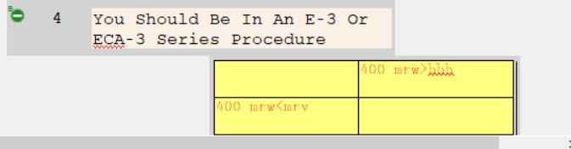

Changes/Additions to User Documentation: NA

