June 25, 2026

Applicability: GEN

Internal Release Information:

B2026-052 - Issue when parens inside a Hardspaced Multi-RO Return Values.
PROMS crashes when doing an update ROFst.
- [Check this box if a sql query or a data fix applies to this update].

Generic External Release:
Added ability to be able to have parenthesis inside a Hardspaced Multi-Return RO Value.

Plant Specific Information for Release Letter:
None

Testing Requirements:
- Use Vogtle Data and open to an EOP.
- Using the RO Editor, change the following setpoint value to contain a parenthesis (P22).
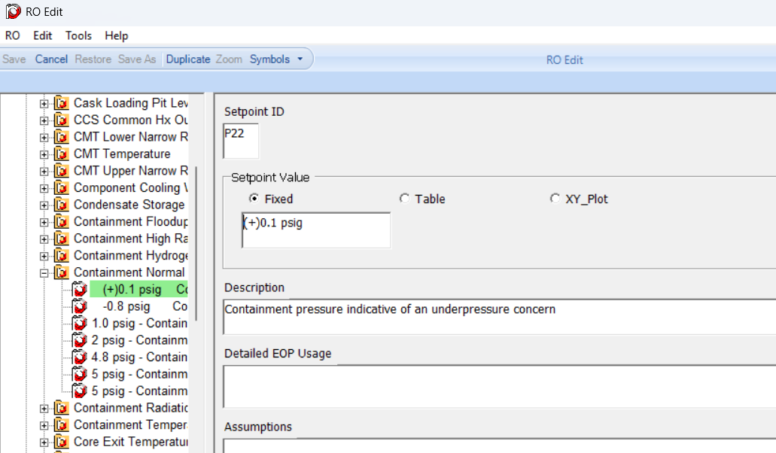
- Create a new RO FST and update RO values. It should not error-out.
Current offending RO is: ContentIDs: 595101, 595103
- Test multiple Hardspaces – Change or create a RO so that it contains multiple @HSP(…) for example:
{{A=@HSP(<Setpoint Value>)}{B=<Description> @HSP(test hardspace)}{C=(<Setpoint ID>)}}
- Create a new RO FST and update RO values.
- Add the new/modified RO to a step.
- In the RO editor, make a change to the RO.
- Create a new ROFST and update RO values. It should not error-out.

Changes/Additions to PROMS Manual and Training Videos:
[Do not use this section – for MRV/DMJ use]
- CSM submitted for PROMS User Manual: ____________.
- CSM submitted for training videos: ____________.

