September 30, 2026

Applicability: Farley

Internal Release Information:
F2026-023
Code fix to so that single Notes do not get a bullet when there is also a Caution following it. In the SAMG format, turned off the bolding the step tabs for the Supplemental Information. In the EOP format, turn on bolding for the standard high level steps and turned off the bolding of the RNO steps and adjust the position of the high level step tab so that two digit step numbers don’t print into the checkoff line.

- [Check this box if a sql query or a data fix applies to this update].

Generic External Release:
N/A

Plant Specific Information for Release Letter:
N/A – is part of the task to change the formats fonts to Arial – customer does not have the formats that use Arial yet – these items were found during testing.

Testing Requirements:
Use Farley data
- Update formats
- Print the Unit 1 SAMG procedureFNP-SAG-1.
- Verify the Note in step 13.1.2 does not have a bullet.

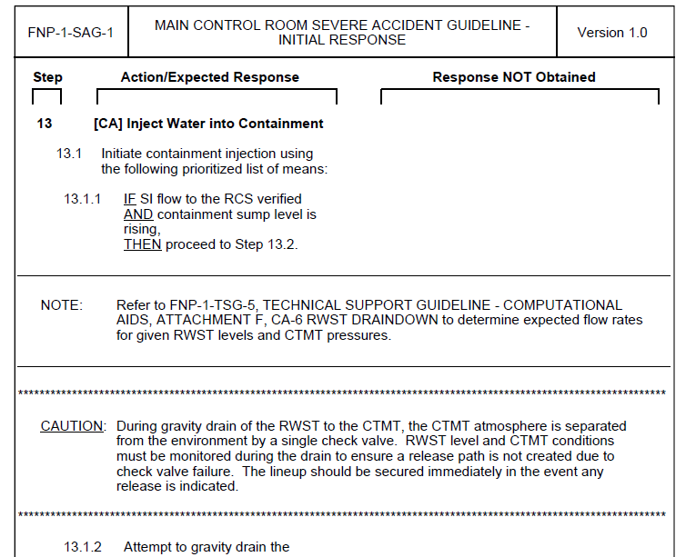

- Print the SAMG procedure SAG-3
- Verify the Supplemental Information text and tabs are not bold

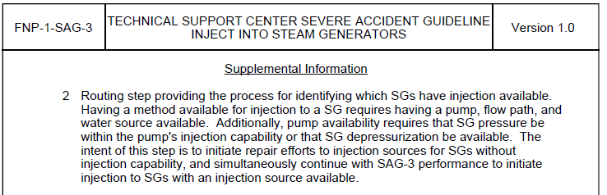

- Edit EOP procedure FNP-1-EEP-0
- Verify the high level steps are bolded and the RNO off of them are not bolded.

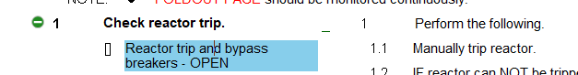
- Print the procedure
- Verify the step tab for step 20 does not print into the checkoff line on the left.

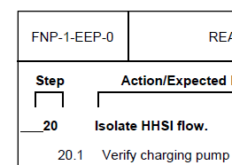

Changes/Additions to PROMS Manual and Training Videos:
[Do not use this section – for MRV/DMJ use]
- CSM submitted for PROMS User Manual: ____________.
- CSM submitted for training videos: ____________.

