September 24, 2024

Applicability: All Plants

Internal Release Information:
B2024-074 When Deleting annotations via the Administrative Tools -> Delete -> Delete Annotations, and checking if a procedure is checked out prior to deletion:
- If no Number for Procedure, Display Title.
- If only deleting annotations from an individual procedure, verify can check out procedure.

- [Check this box if a sql query or a data fix applies to this update].

Generic External Release:
Improved messaging related to deleting annotations via the administrative tool. If procedures do not have a procedure number and are checked out, procedure title will now be displayed in the messaging.

Plant Specific Information for Release Letter:
N/A

Testing Requirements:
- Use any plants database
- Open PROMS as a particular user
- Add an annotation to a Procedure
- With that session still active / that procedure still checked out, open a 2nd session of PROMS using a different user.
- Navigate to the Administrative Tools
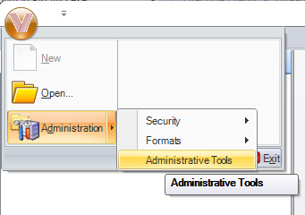

- Select to Delete and Delete Annotations:
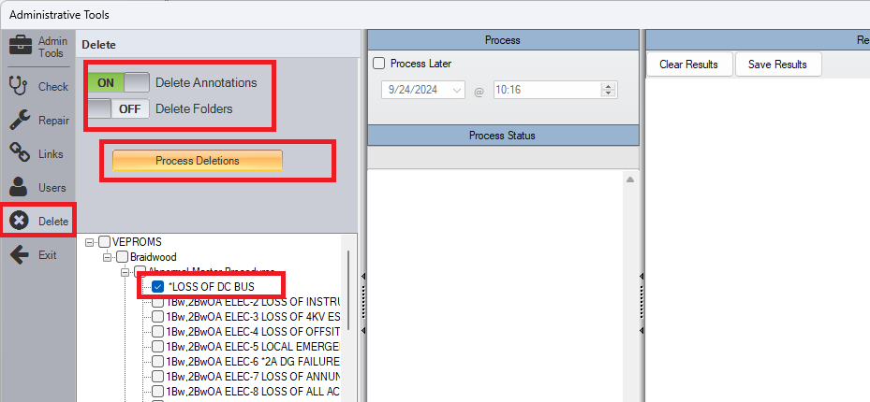

Test Case 1: If no number for a procedure, procedure title should be outputted in error message:
- If you right Click on a particular procedure and select Properties, if Number is blank:
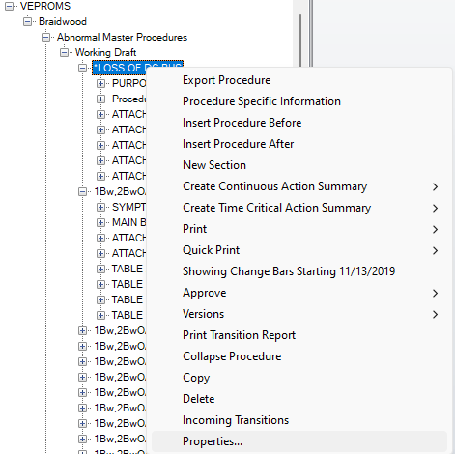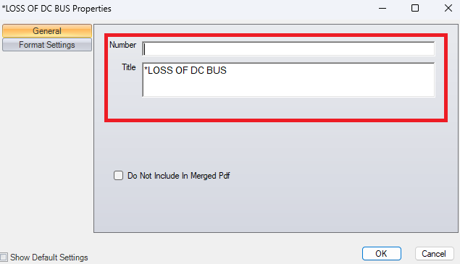

- The Output from the Administrative Tools check should reflect the procedure title.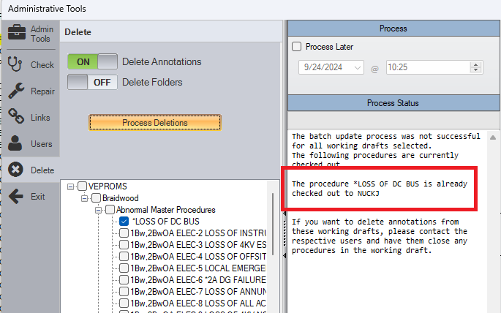

Test Case 2: (Negative Test) If number for a procedure exists and it is checked out, procedure number should be outputted in error message from test.
- The Output from the Administrative Tools check should reflect the procedure number.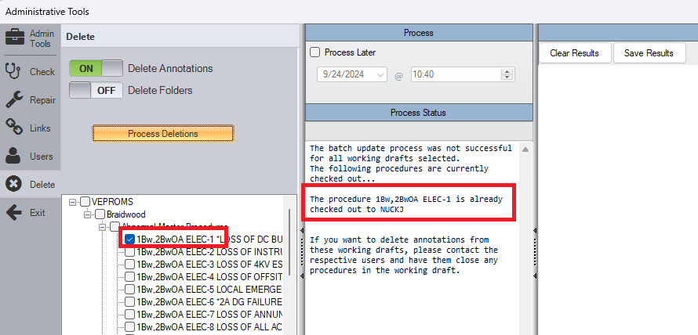

Test Case 3: If a procedure set is selected and an underlying procedure is checked out, message for a checked-out procedure should only occur once (i.e. there should not be duplicate messages for the same procedure (one from the set and a second from the individual procedure)).
- Message should only occur once.
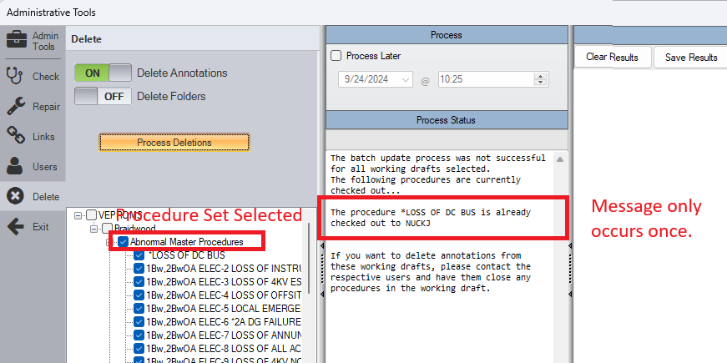

Test Case 4: (Negative Test) If nothing is checked out (close original session of PROMS), deletion should be able to proceed.

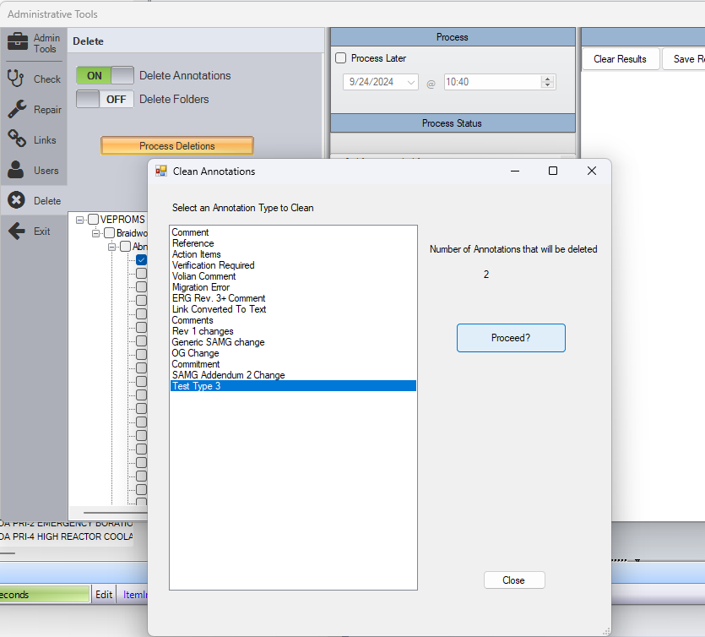

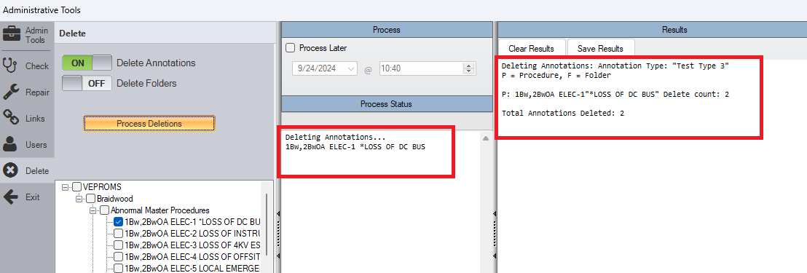

Changes/Additions to PROMS Manual and Training Videos:
[Do not use this section – for MRV/DMJ use]
- CSM submitted for PROMS User Manual: ____________.
- CSM submitted for training videos: ____________.

