July 1, 2024

Applicability: Beaver Valley

Internal Release Information:
F2024-064
Beaver Valley requested that the section number be underlined at the top of the pages and the spacing after the title on continued pages corrected on:
- “Beaver Valley Single Column Format” (BVPSATCH) - Two Column Attachment section style
- “Beaver Valley AOP Format” (BVPSAOP) – Two Column Attachment, Attachment w/ Section Number and Title and Attachment w/ Section Number and Title (including END)

- [Check this box if a sql query or a data fix applies to this update].

Generic External Release:

N/A

Plant Specific Information for Release Letter:
Beaver Valley
The following changes have been made to Beaver Valley formats:
- “Beaver Valley Single Column Format” (BVPSATCH) - Two Column Attachment section style
- “Beaver Valley AOP Format” (BVPSAOP) – Two Column Attachment, Attachment w/ Section Number and Title and Attachment w/ Section Number and Title (including END)

Testing Requirements:
Use Beaver Valley data
- Update formats
- Change the format to Beaver Valley Single Column Format (BVPSATCH) and change the section style of AOPs/Unit 1/AOP 1.15.1/Attachment 1 to “Two Column Attachment”
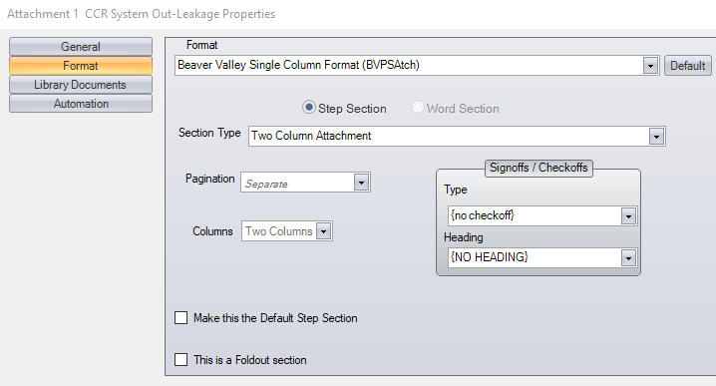

- Print the procedure and verify the section number is underlined and there is extra space between the top continued message and the first line procedure text.
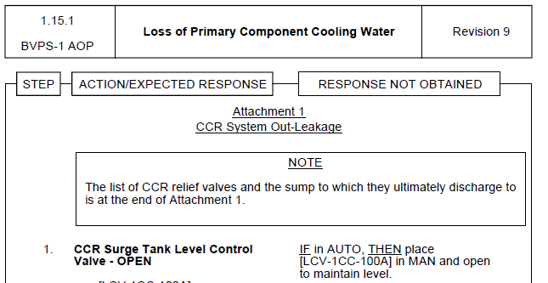

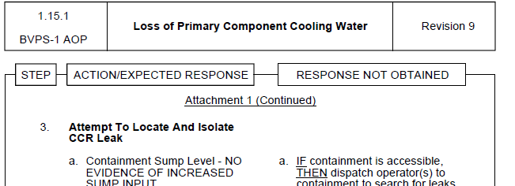

- Change the format to Beaver Valley AOP Format (BVPSAOP) and change the section style of AOPs/Unit 1/AOP 1.15.1/Attachment 1 to “Two Column Attachment”
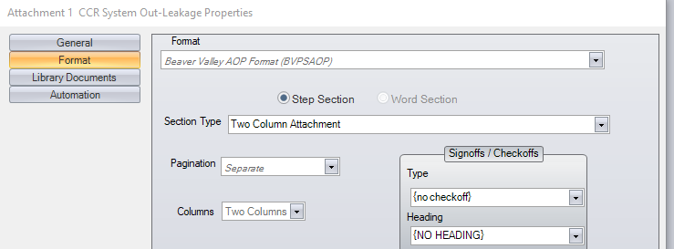

- Print the procedure and verify the section number is underlined and there is extra space between the top continued message and the first line procedure text

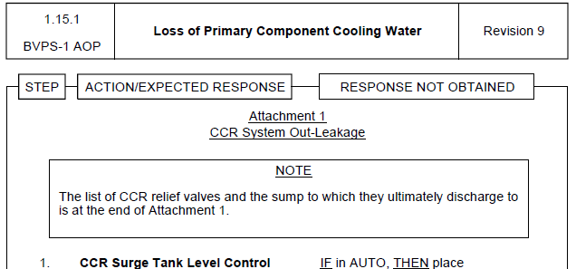

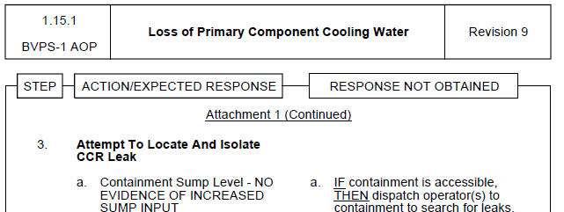

- Change the format to Beaver Valley AOP Format (BVPSAOP) and change the section style of AOP dual unit 75.1, attachment 5 to “Attachment w/ Section Number and Title”
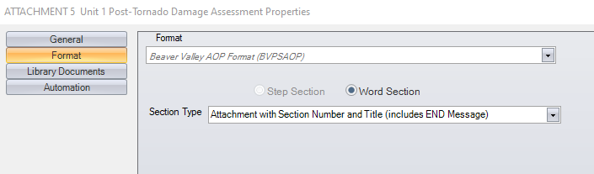

- Print the procedure and verify the section number is underlined and there is extra space between the top continued message and the first line procedure text
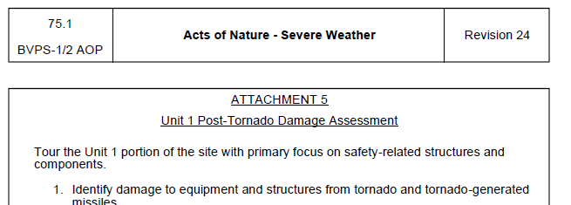
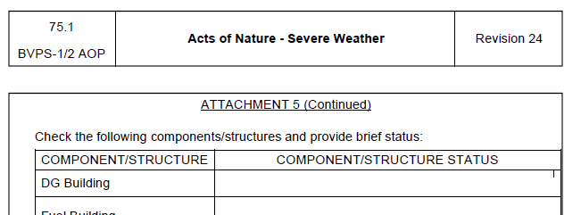

- Change the format to Beaver Valley AOP Format (BVPSAOP) and change the section style of AOP unit 1, 1.6.5 attachment 10 to “Attachment w/ Section Number and Title (including END)”
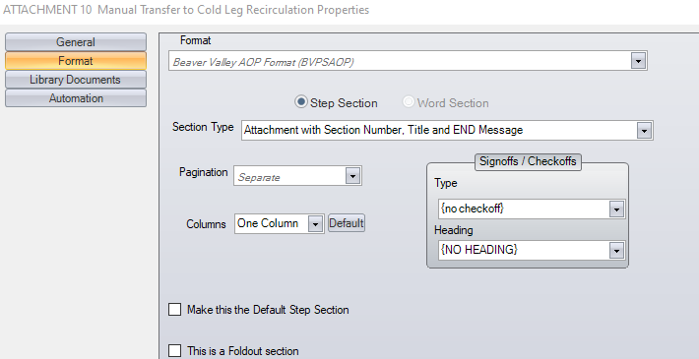
- Print the procedure and verify the section number is underlined and there is extra space between the top continued message and the first line procedure text
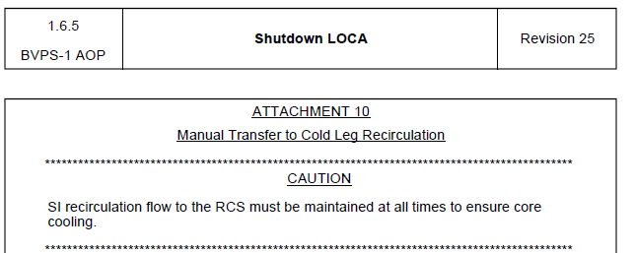

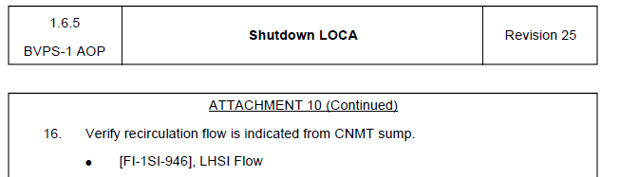

- Change the format to Beaver Valley AOP Format (BVPSAOP) and change the section style of AOP unit 1, 1.6.5 attachment 10 to “Attachment w/ Section Number and Title”
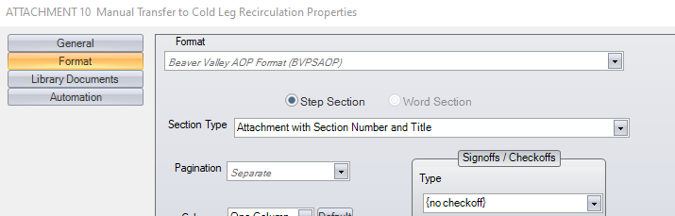
- Print the procedure and verify the section number is underlined and there is extra space between the top continued message and the first line procedure text
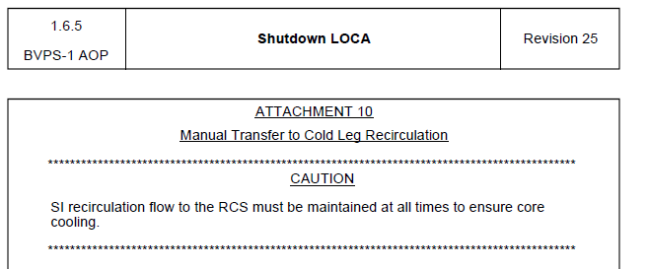
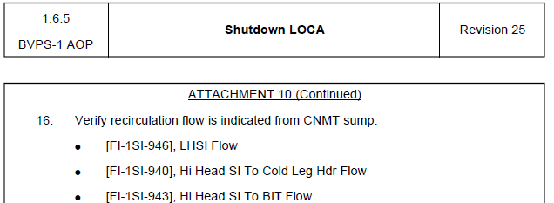

Changes/Additions to PROMS Manual and Training Videos:

No changes needed for the user manual nor the training videos

- CSM submitted for PROMS User Manual: ____________.
- CSM submitted for training videos: ____________.

