January 9, 2025

Applicability: All Plants

Internal Release Information:
B2025-003 Chronology/Summary of Changes Reports

Instances were found where certain ContentAudits did not have ActionDTS on them due to being created and modified within seconds of being created. As a result, these items showed on the Chronology/Summary of Changes Reports as 1/1/0001 12:00 AM. Made a change so that if the ActionDTS is missing or less than the item DTS it will show the M/dd/yyyy of the itemDTS instead.

- [Check this box if a sql query or a data fix applies to this update].

Generic External Release:
Improved readability of dates on the Chronology/Summary of Changes Reports when changes occur immediately after an item is created.

Plant Specific Information for Release Letter:
N/A

Testing Requirements:
- Use any plants database (this specifically was found Using the AEP database for testing change bars (while working on the PROMS manual) – specifically a summary of changes on procedure FR-S.1)
- Another example is the Chronology Report – DC Cook – Current (Post FLEX) Unit 2 FR-S.1
- Doing the report, in these cases, it should now just show the Month/day/Year from the itemDTS
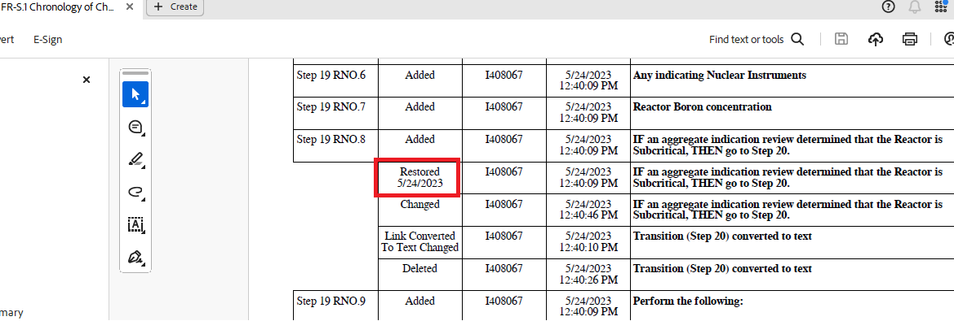

Changes/Additions to PROMS Manual and Training Videos:
[Do not use this section – for MRV/DMJ use]
- CSM submitted for PROMS User Manual: ____________.
- CSM submitted for training videos: ____________.

