Applicability: F2023-076: PROMS User Manual transition formatting

Internal Data Fixes: NA

Internal Release:

F2023-076: PROMS User Manual transition formatting. For Section Number/Title with/without Step type transitions, an extra ‘)’ was included as part of the transition text. This was introduced

Generic External Release: NA

Plant Specific Information for Release Letter: NA – PROMS User Manual

Testing Performed:

See Testing Required.

Testing Requirements:

Using Proms User Manual sql database:
£ Open PLANT SPECIFIC FUNCTIONS/G.11 Place Keepers/G.11.3.1 and insert a step below.
£ In the new step, add a Section transition (2nd from bottom of list), selecting Procedure Set PRINT and Section C.1.1, don’t Include Step Number and Include Step Number to verify that there are no extra parenthesis within transition text

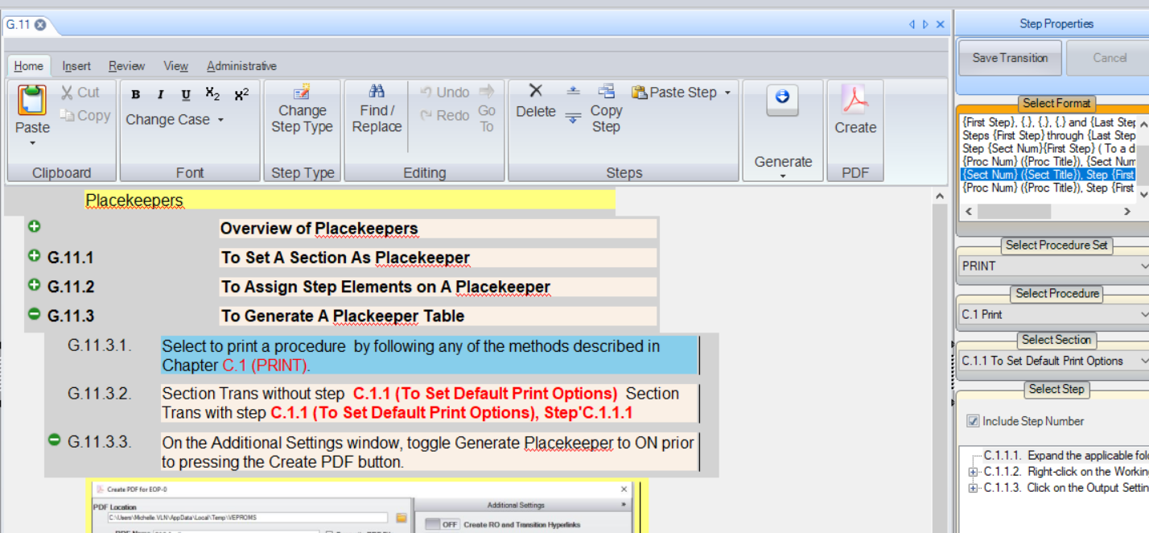

Using Beaver Valley sql database:
£ Open an AOP procedure to a PROCEDURE section
£ Add a test sub-step and insert a transition using the {Section Number}/{Step Number} to a different section transition type
£ Select a different section and uncheck the Include Step Number check box
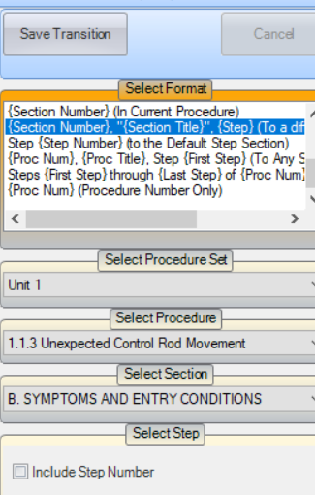
£ Verify the transitions is inserted and it does not have “, Step” preceding it and has correct double quotes surround section title
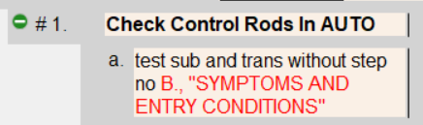

£ Add a another test sub-step and insert a transition using the {Section Number}/{Step Number} to a different section transition type
£ Select a different section, keep checked the Include Step Number check box
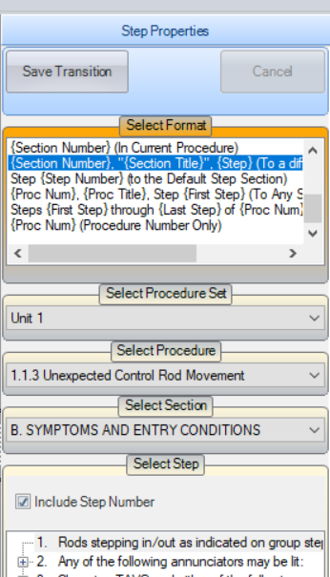
£ Verify the transitions is inserted, has “, Step” and has correct double quotes surround section title
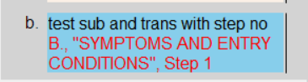

Changes/Additions to User Documentation: NA

