July 12, 2024

Applicability: Barakah

Internal Release Information:
B2024-039
Customer reported that transitions to standard text get converted to text when the Refresh Transitions is done from the Admin Tools

- [Check this box if a sql query or a data fix applies to this update].

Generic External Release:
N/A

Plant Specific Information for Release Letter:
Barakah
The Refresh Transitions Admin Tool will now refresh the Standard Text transitions without converting them to text.

Testing Requirements:
- Use Barakah data
- Update formats
- Open an EOP procedure to the Instructions and Contingency Actions section and add a test step
- In the test step, add a transition to standard text using the “{Step Text} (Standard Procedure Step Text)” transition type and selecting from standard step procedure

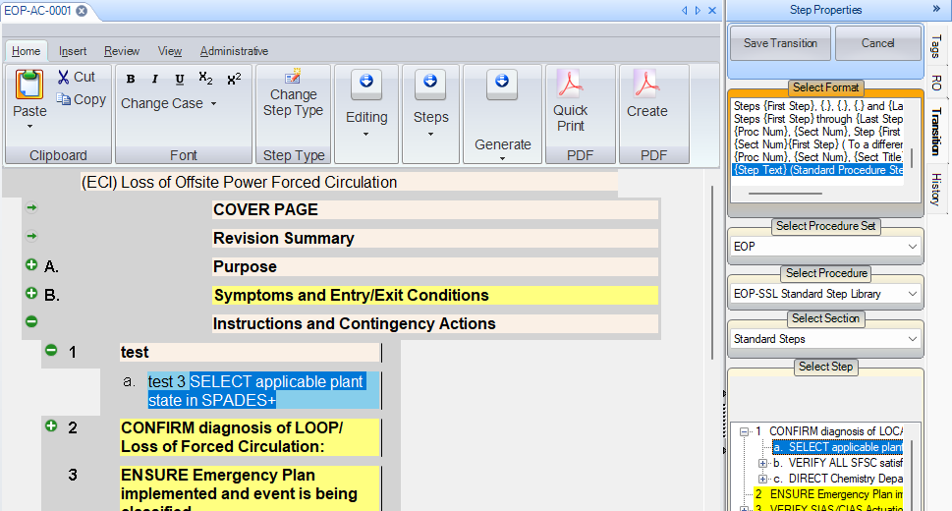

- Close the procedure.
- Open Admin Tools and run the refresh transitions on that procedure
- Verify the transition you entered was not converted to text

Changes/Additions to PROMS Manual and Training Videos:
[Do not use this section – for MRV/DMJ use]
- CSM submitted for PROMS User Manual: ____________.
- CSM submitted for training videos: ____________.

