February 3, 2026

Applicability: All Plants (found on Vogtle 3&4)

Internal Release Information:

B2026-011 Improve the resolution of unit numbers in multi-unit background documents when printing.

Multi-Unit Background documents --- Found this while looking at background Documents for Vogtle 3/4 --- particularly AOP-101 -> Operator Actions -> Step 2: Note 2.

When there is a unit designator (like <U-NAME>-AOP-101. ) in the note's text, PROMS renders the text and pulls it over as text only to the background document.

This causes printing the background document to print as if both units instead of resolving if a specific unit is being printed.

- [Check this box if a sql query or a data fix applies to this update].

Generic External Release:
Improve the resolution of unit numbers in multi-unit background documents when printing.

Plant Specific Information for Release Letter:
None (This was found prior to delivering the AOPs for Vogtle 3 & 4)

Testing Requirements:
- Use latest Vogtle 3 & 4 data
(Copy saved at: V:\Proms Versions\Test Version\Data to use for testing\B2026-011)
- Open Background documents for AOP-101
- You should get a prompt – Click Yes on the prompt:
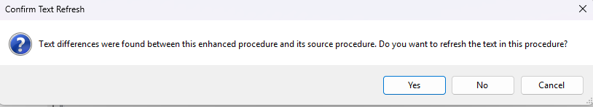
- Printing for Unit 4 should properly resolve the U-NAME unit designator in Background Documents for particularly AOP-101 -> Operator Actions -> Step 2: Note 2
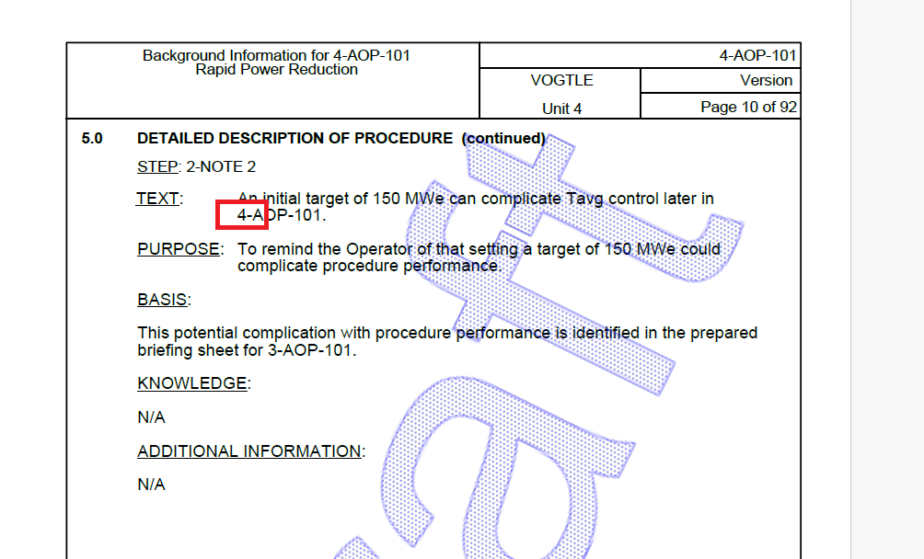

Changes/Additions to PROMS Manual and Training Videos:
[Do not use this section – for MRV/DMJ use]
- CSM submitted for PROMS User Manual: ____________.
- CSM submitted for training videos: ____________.

