May 29, 2025

Applicability: GEN

Internal Release Information:
C2025-023 Electronic Procedures - Modifications to PROMS (Phase 1)

At the completion of this phase, we should be able to demonstrate ability of PROMS to capture and edit the basic information needed for use in Electronic Procedures.

note that this is a sub-item of:
C2024-032 Electronic Procedures – POC

- [Check this box if a sql query or a data fix applies to this update].

Generic External Release:
Added generic support in PROMS to be able to store and modify data related to Electronic Procedures.

Plant Specific Information for Release Letter:
N/A

Initial Setup (for EP use in any DB):
- Use any Plants DB
Note that testing exe and groupings will be located here:
V:\Proms Versions\Test Version\Data to use for testing\C2025-023

- Create a new Annotation Type to use as an EP Annotation Type
- Create EP Format file in epall folder (example EPFortmatTST1.xml)
- Add reference in main format file to EP format file (and also reference to related annotation type). Example (EPTST1all.xml):
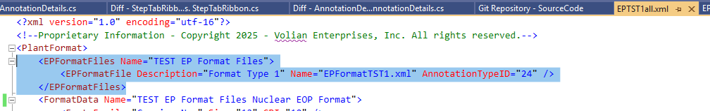
- Format must be in use when start PROMS (note: it basically checks for in use format files with the lines above and marks the referenced Annotation Types as being “Electronic Procedure Annotation Types”)
- Start PROMS and update / add new formats
- Note: It is recommended to do a full db backup before any changes are done to the Electronic Procedure xml file.

Testing Requirements:
- Use any DB that has been set up for EP use.
- Instructions for Initial Setup of EP use in a DB is above
- There is also a preset up DB with preset up ROs at: V:\Proms Versions\Test Version\Data to use for testing\C2025-023
- After setup, should be able to view EPFormats and EP Annotation Type in the DB
- SELECT * FROM EPFormats
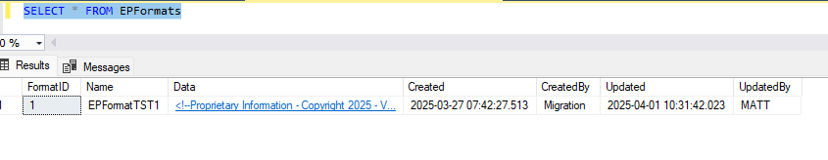
- SELECT * FROM AnnotationTypes where IsEPAnnotationType = 1
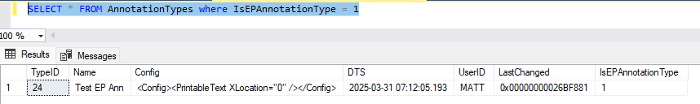

If you go to a step, and create – then select an Annotation of the “EP Annotation Type” then you should get an Open option
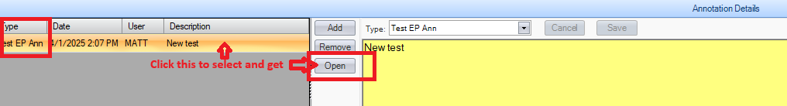
- Selecting Open should bring up the fields from the EP format file. The fields that will show / be accessible will depend on the step type of the step that the annotation is attached to:
For example, if it is a substep, and the EP Format file looks like:
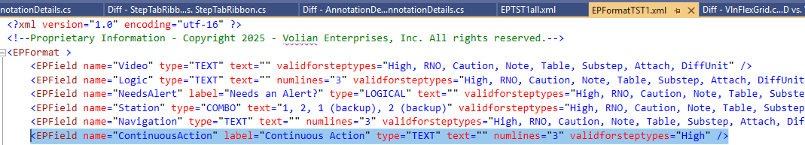
Then Continuous Action would not show
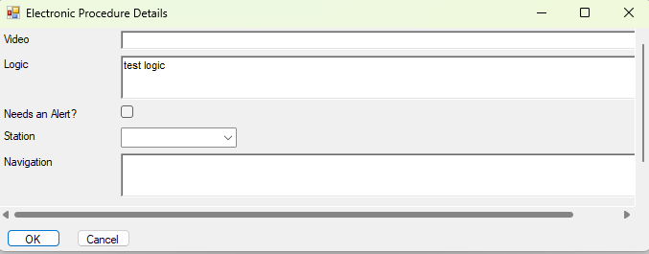
- Form should appropriately display, resize, show, save data, and recall data (once enter, click ok, navigate off annotation/step and then back)
- Need to test that EP items based on RO Lists display, resize, show, save data, and recall data (once enter, click ok, navigate off annotation/step and then back)
- There are 2 types of items based on RO Lists – “ROMULTI” & “ROSINGLE” – this will designate if list is multi select or single select.
- Items are tied to the ROID of a group item.
For Example:

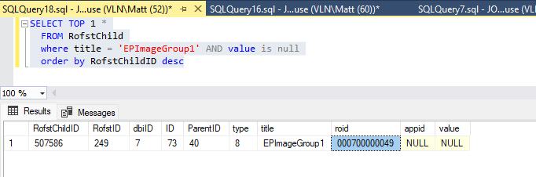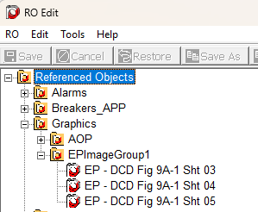
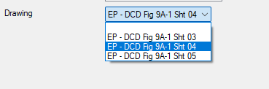

- Need to test designation and storage of designation for marking a cell (or cells) in a table as having a checkbox or textbox in an Electronic Procedure Viewer.
- Add or open an EP Annotation that is attached to a table in PROMS
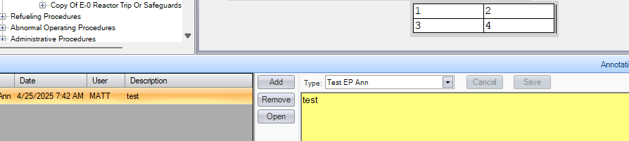

- Editing should have the new EP table input control
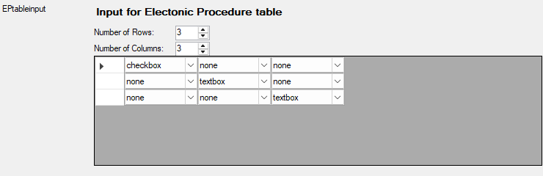

- Control should appropriately adjust depending on number of rows / columns selected
- Information should persist (save when form submitted and re-load when re-opened after a submission).
- Default should be “None”
- If no information previously entered / saved will default to a 1x1 table

Changes/Additions to PROMS Manual and Training Videos:
[Do not use this section – for MRV/DMJ use]
- CSM submitted for PROMS User Manual: ____________.
- CSM submitted for training videos: ____________.

