March 14, 2024

Applicability: Commanche Peak

Internal Data Fixes: N/A

Internal Release:
F2024-044
Underline the Note tabs in the Commanche Peak ERG format.

Generic External Release:
N/A

Plant Specific Information for Release Letter:
Commanche Peak
Commanche Peak ERG format
Note tabs will now be underlined

Testing Requirements:
Use Commanche Peak data
- Update formats
- Open to step 5 of EOP-0.0 in the ERG Master
- Verify the Note tab is underlined.

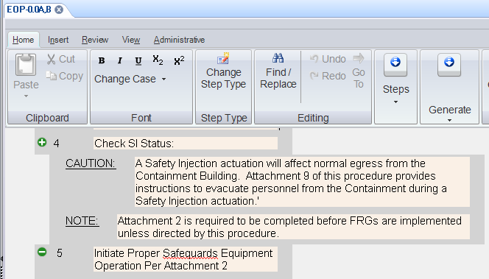

- Print the procedure and verify the Note tab is underlined

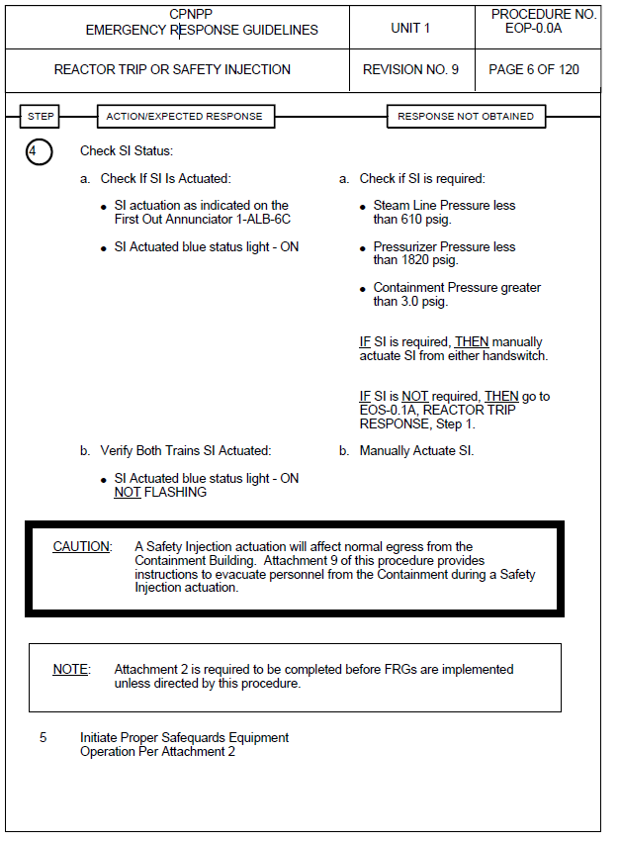

Changes/Additions to User Documentation:

N/A

