January 24, 2024

Applicability: Vogtle Units 3 & 4 Alarms

Internal Data Fixes: N/A

Internal Release:
F2024-006
Fixed pagination logic to that step text at the bottom of an Alarm Point page does not print on top of the bottom continue message

Generic External Release:

N/A

Plant Specific Information for Release Letter:
Vogtle Units 3 & 4
The PROMS pagination logic for the Alarm procedures was adjusted to better determine where to paginate, based on the amount of step text and type of step text.

Testing Requirements:
Use Vogtle Unit 3 & 4 data

- Print Alarm Point DAS-ARP-011.
- Verify the Operator Actions section paginations as depicted below:

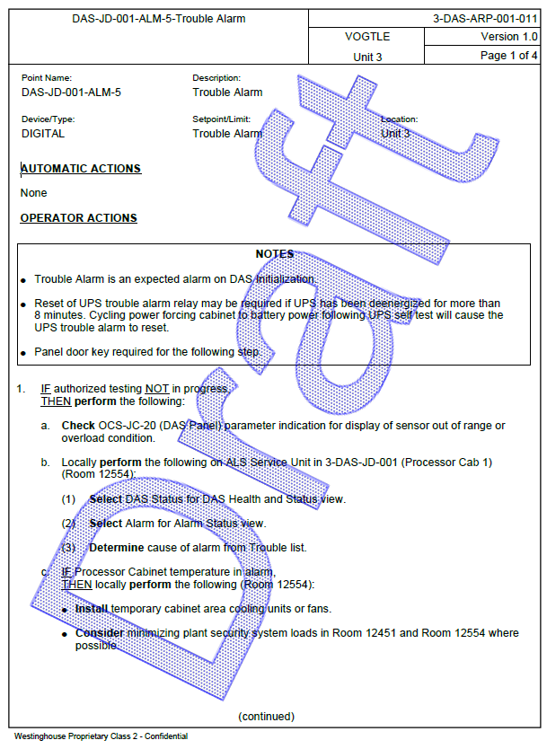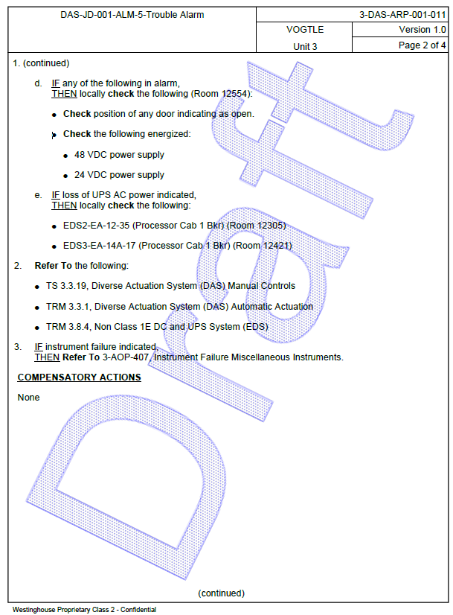

- Print Alarm Point DAS-ARP-018.
- Verify the Operator Actions section paginations as depicted below:

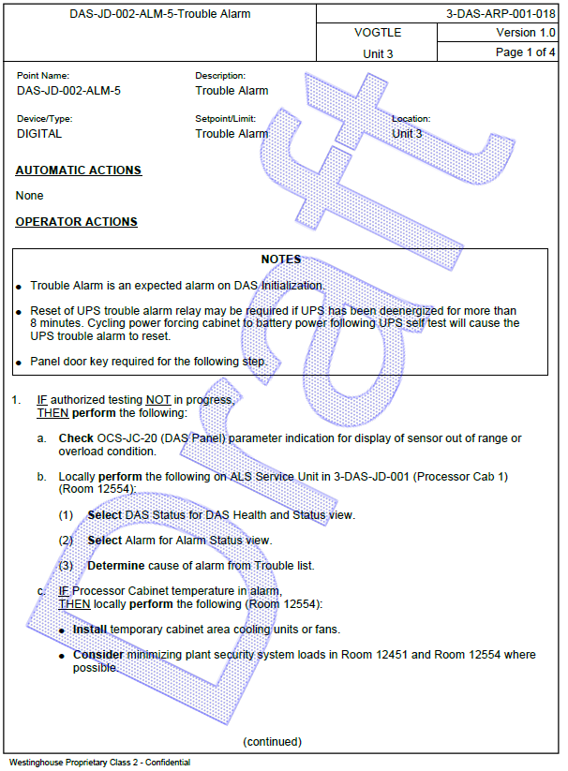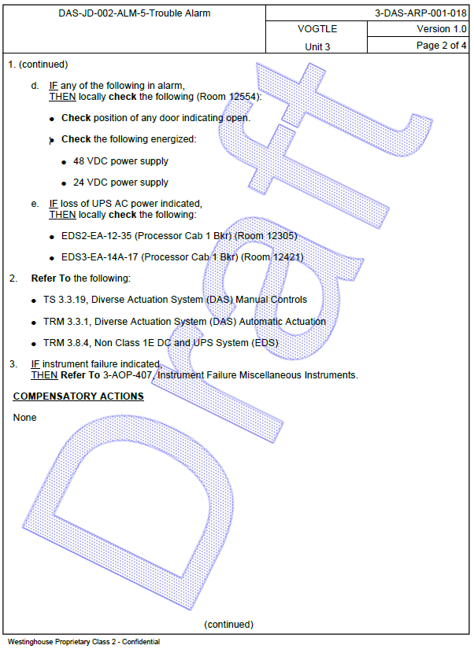

- Print Alarm Point DAS-ARP-018.
- Verify the Operator Actions section paginations as depicted below:

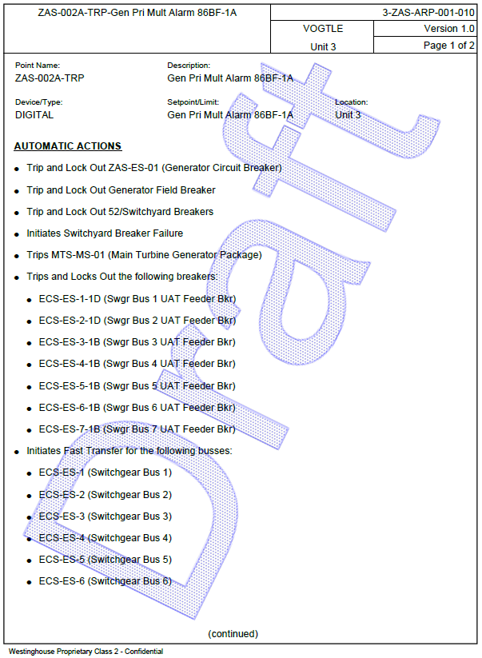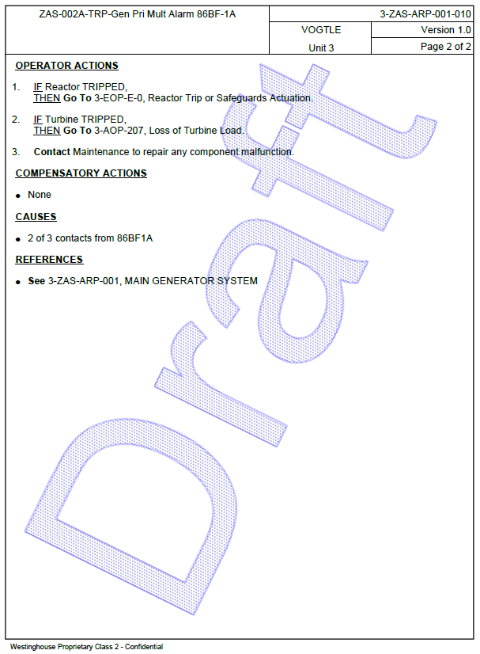

Changes/Additions to User Documentation: N/A

