December 12, 2024

Applicability: Manual

Internal Release Information:
F2024-086 In the PROMS Manual format in the Attachments (Step Editor) With Border section type, the page number needs centered horizontally on the page (it's located between the section number and section title.

- [Check this box if a sql query or a data fix applies to this update].

Generic External Release:
In the Manual, shifted page designation for Attachments (Step Editor) With Border section type left to provide a more centered appearance.

Plant Specific Information for Release Letter:
N/A

Testing Requirements:
- Use Manual db
- print Attachment 1 of Chapter C.1.
previously Page was not showing centered under the attachment heading
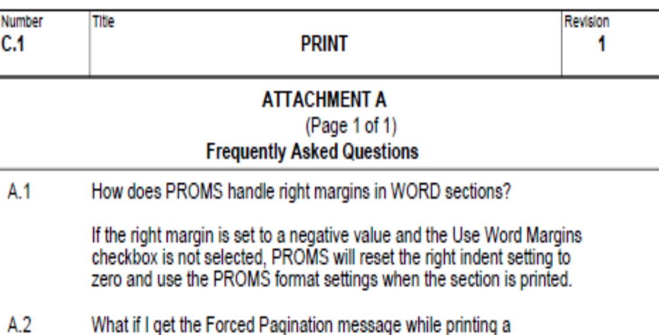

Changes/Additions to PROMS Manual and Training Videos:
[Do not use this section – for MRV/DMJ use]
- CSM submitted for PROMS User Manual: ____________.
- CSM submitted for training videos: ____________.

