7/31/2024

Applicability: All

Internal Release Information:
B2024-045, B2024-049 and B2024-050
B2024-045: Copy of figure and subsequent paste/replace crashes with a sql error:

B2024-049: Copy of Note and subsequent paste/replace crashes with a sql error:

B2024-050: The program crashes when replacing a procedure in which only a single procedure is listed in a working draft.

NOTE that the B2024-045 and B2024-049 were introduced during the Copy procedure work for B2024-042. B2024-050 has existed for a while, this will be only item listed for the Generic External Release Note.
☐ [Check this box if a sql query or a data fix applies to this update].

Generic External Release:
The program no longer crashes when replacing a procedure in which only a single procedure is listed in a working draft.

Plant Specific Information for Release Letter:
N/A

Testing Requirements:
Use any database, the Manual sql database was used for these tests:

B2024-045 Copy of figure and subsequent paste/replace crashes with a sql error:
- Expand PRINT/C.1.1.2 in the editor
- Copy the first image under the step
- Position on the second image under the step and Paste Replace over it to verify that the program does not crash and the copied image is pasted:
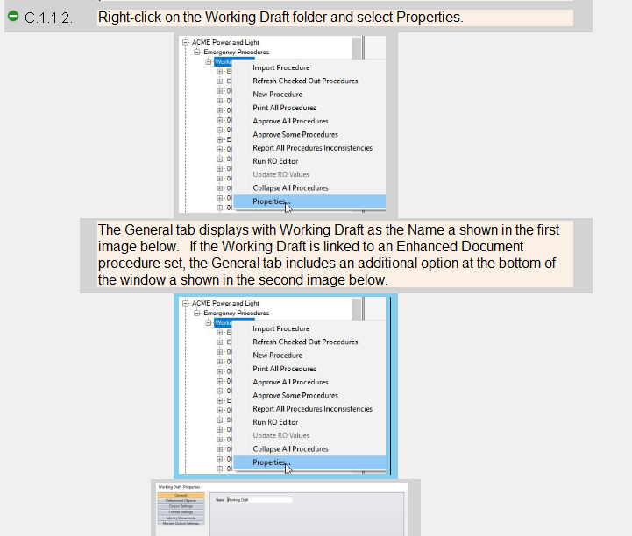

B2024-049 Copy of Note and subsequent paste/replace crashes with a sql error:
- Expand PRINT/C.1.1.1 in the editor
- Copy the second note
- Insert another Note after the second and then, do a Paste Replace when positioned on the newly inserted Note to verify that the program does not crash and the copied Note is pasted:
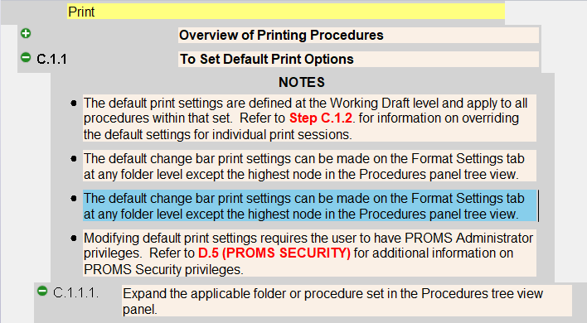

B2024-050 Copy and replace of procedure when it is only procedure in folder crashed:
- If a single procedure in a Working Draft doesn’t exist in the current database, create a new folder, new working draft in that folder and procedure in that working draft
- Select a procedure from another folder/Working Draft (not that from first step) and right click to select “Copy”
- Select the single procedure in the first step and open it by clicking on it.
- Right click to select “Replace Existing Procedure”
- Verify that the confirmation message appears.
- Click “Ok” to replace the selected procedure. Verify that the program doesn’t crash
- The procedure in the tree view on the left should be the copied procedure

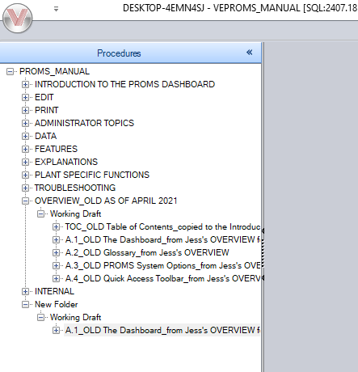

Changes/Additions to PROMS Manual and Training Videos:
☐ CSM submitted for PROMS User Manual: _______________________________________

☐ CSM submitted for training videos: _______________________________________

