October 9, 2024

Applicability: All Plants

Internal Release Information:
C2024-024 Simple Selection of Fields to add to Return Values and Menu Values.

Once In Use Fields have been specified for a Referenced Object Definition, Right Clicking on an in-use field, will bring up a menu option allowing it to be added to the Return Value or Menu Value. "Return Value" and "Menu Value" boxes will retain current functionality allowing manual entry in addition to the new feature. This option will be made available both for the:
• Referenced Object Definition
• Subgroup Definition

Enhancement - Part of 2024 PROMS upgrades.

- [Check this box if a sql query or a data fix applies to this update].

Generic External Release:
Enhancement added to RO Editor. Once In Use Fields have been specified for a Referenced Object Definition, right mouse clicking one of these In Use Fields should allow them to be added to the Return Values / Menu Values, saving the user time of having to manually type the field name and reducing the possibility of a typo by typing an incorrect field name.

Plant Specific Information for Release Letter:
N/A

Testing Requirements:
- Use any plants database that has ROs. Will also need to run at least 1 test with a plant that has ROs and Applicability (Braidwood is an example). Open the RO Editor
- Use any RO Group or create a new group and add fields to the In Use List
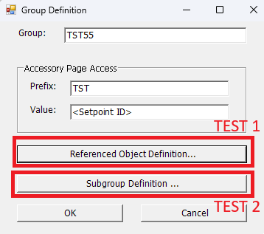
- Right Clicking on an item from the In Use List should add them to the appropriate box. If a field is added and there is already text in the box a “ – “ will be added as a delimiter.
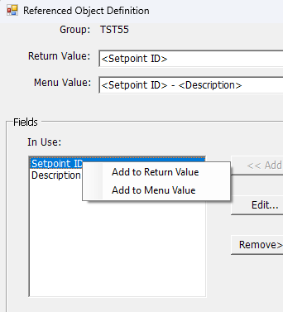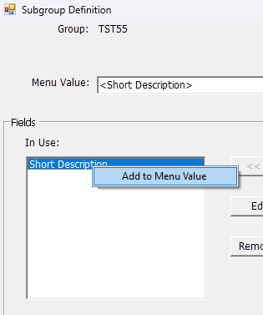

- Note: This needs to be tested both for ROs with and without Applicability (since both have different controls). For Testing with applicability, run RO Editor from a section in PROMS with Applicability enabled. (Will have the checkboxes in the Editor Windows to the left of the list items)
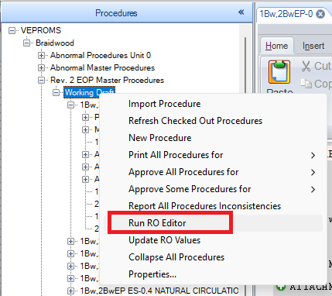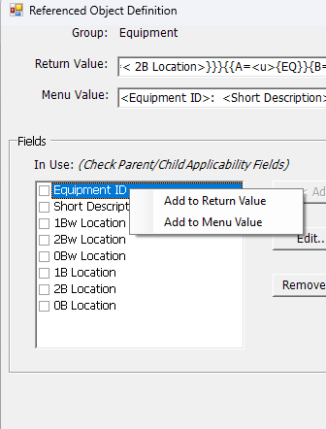

Changes/Additions to PROMS Manual and Training Videos:
[Do not use this section – for MRV/DMJ use]
- CSM submitted for PROMS User Manual: ____________.
- CSM submitted for training videos: ____________.

