March 20, 2025

Applicability: All Plants

Internal Release Information:
C2024-041 Disable-UCF-(User-Control-of-Format)-options. Remove all options under the format menu option in the Administration in the V Menu. Change the “Formats” option to” Update Formats”

Generic External Release:
The Administration Menu in the V menu has been modified. The “User Control of Formats”, “Export User Control of Formats”, “Import User Control of Formats”, and “Formats”. “Formats” has been replace by “Update Formats”.

Plant Specific Information for Release Letter:
N/A

Testing Requirements:

- Open PROMS.
- Navigate to Administration menu in the V menu.
- Verify that the flyout menu appears like this screen shot.

- 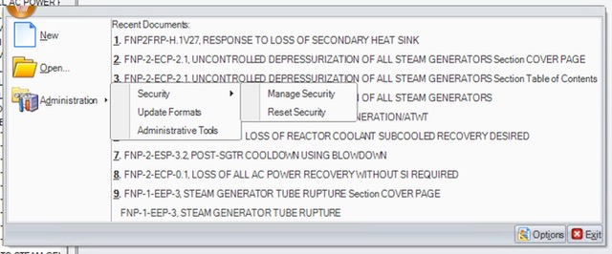

- Make sure all the menu options still work.

- Click on the Options button in the V menu.

- Verify that the “UCF Import Options” panel has been removed from the “Proms System Options” Panel.

- 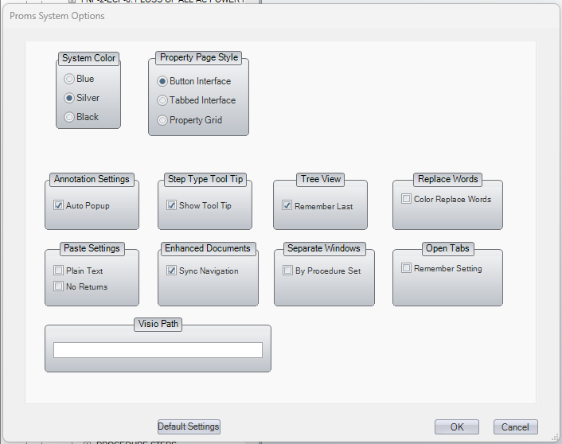

Changes/Additions to PROMS Manual and Training Videos:
[Do not use this section – for MRV/DMJ use]
- CSM submitted for PROMS User Manual: ____________.
- CSM submitted for training videos: ____________.

