January 14, 2026

Applicability: Vogtle Units 3 & 4

Internal Release Information:
F2026-001
Added the ability to prefix a Continuous Action sub-step tab with its parent tab.

- [Check this box if a sql query or a data fix applies to this update].

Generic External Release:
N/A

Plant Specific Information for Release Letter:
N/A – format and data currently under development.

Testing Requirements:

Test One:

Use Vogtle Units 3&4 data
- Update formats
- Open EOP procedure E-3
- Generate a Continuous Action Summary
- Verify CAS steps highlighted in the screenshot below appear the same as the one you generated

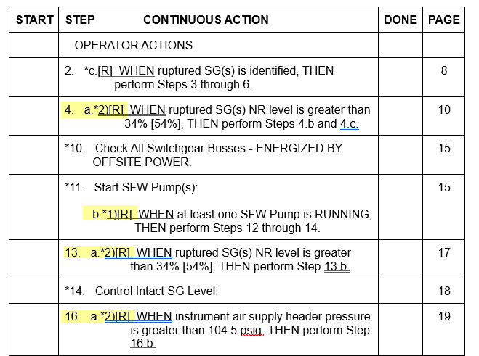

Test Two:

Use Farley data
- Update formats
- Open EEP-0 in the Rev 3 Unit 1 ERPs procedure sets
- Generate a Continuous Action Summary
- Verify CAS steps highlighted in the screenshot below appear the same as the one you generated

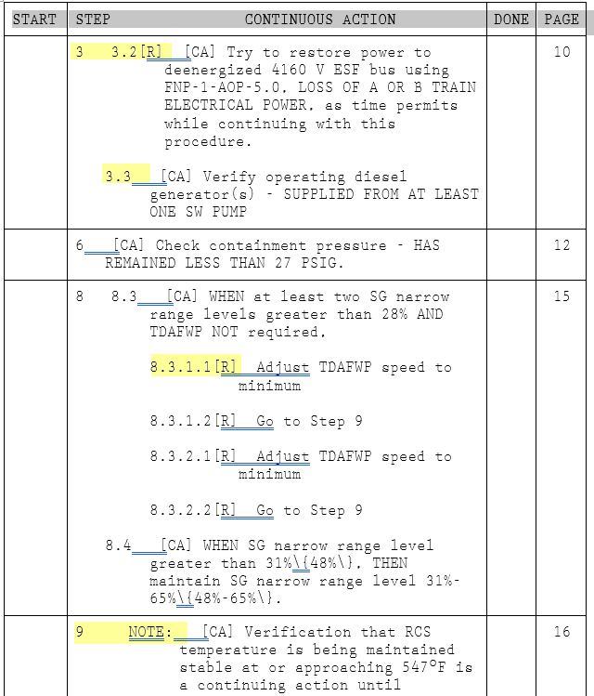

Changes/Additions to PROMS Manual and Training Videos:
[Do not use this section – for MRV/DMJ use]
- CSM submitted for PROMS User Manual: ____________.
- CSM submitted for training videos: ____________.

