May 14, 2025

Applicability: GEN

Internal Release Information:
B2025-028 RO Editor - Parent Child Applicability - Default Values

While working with parent/child applicability with child applicability set for a setpoint group - assign the Setpoint Values and Short Description fields to have Child values. All child values default to their parent values as expected. However, if you click in the Parent field for the Short Description, the Child Values for the Short Description fields incorrectly defaulted to the Parent Setpoint Value instead of keeping the parent Short Description.

- [Check this box if a sql query or a data fix applies to this update].

Generic External Release:
Improved default text when in RO Editor and leaving a child field that has Child Applicability – It will now default to the Parent text instead of the group parent text. It always correctly defaulted to the parent text when loading, but if entered a child field and exiting it, it would previously change the default to the group parent text.

Plant Specific Information for Release Letter:
N/A

Testing Requirements:
- Use Any data With ROs and Applicability – Open the RO Editor
- Edit an RO with multiple fields with applicability.
- Click in a field for one of the fields other than Setpoint Value.
- When click out of the field – it should default to appropriate text.
- Example:
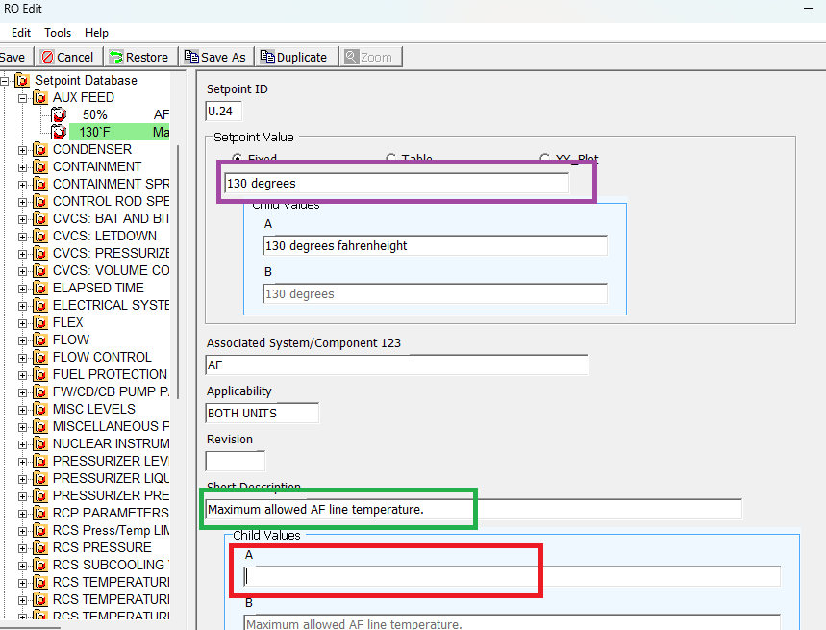
In the example above – if click in the box in red then click out of it – it should get the same text as the box in green --- not the text from the box in purple.

Changes/Additions to PROMS Manual and Training Videos:
[Do not use this section – for MRV/DMJ use]
- CSM submitted for PROMS User Manual: ____________.
- CSM submitted for training videos: ____________.

