January 20, 2025

Applicability: All Plants

Internal Release Information:
C2025-003 Enhanced Copy/Paste Upgrade

Currently, when utilizing copy/paste-replace with enhanced documents, PROMS currently does not allow you to do paste replace over another master step. This is to enable the “Paste Replace” option for this and to prompt the user if they would also like to copy/paste the related background documents. If yes, it will remove the old background document on the step being replaced and create a new background document with the pasted contents. If no is selected, it will keep the existing background document and link the newly pasted step to it. Note that Cautions and Notes will be included as part of the paste/replace.

- [Check this box if a sql query or a data fix applies to this update].

Generic External Release:
Upgraded Enhanced Copy/Paste to now prompt the user if they also want the background steps copied when copying a master step. If yes, it will remove the old background document on the step being replaced and create a new background document with the pasted contents. If no is selected, it will keep the existing background document and link the newly pasted step to it.

Plant Specific Information for Release Letter:
N/A

Testing Requirements:
- Use any plants database that contains Enhanced steps
- In a Source Document, copy a Master Step and do a Paste Replace over top of a different Master Step and select No when prompted “Do you also wish to make a copy of the background documents?”
- Newly pasted should have text from what it was pasted from and should be linked to the pre-existing background step (Only the title of the BG step will be updated to match the new master step wording). Each background Step should only be linked to 1 Source Step, and Go-To Links should work both from the source steps and from the background steps.
- Example:
If copying X over Y from:
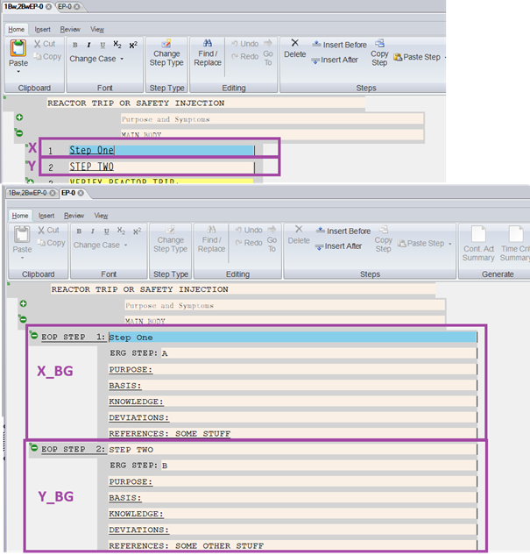
Then
Note: Text on Y & Y_BG1 update but Y_BG2 remains as-is
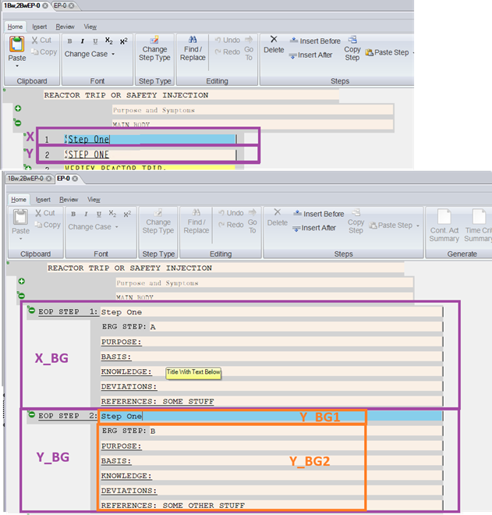

- In a Source Document, copy a Master Step and do a Paste Replace over top of a different Master Step and select Yes when prompted “Do you also wish to make a copy of the background documents?”
- Newly pasted should have text from what it was pasted from and should be linked to a new background step with the same wording as the BG step that was copied from. Any pre-existing BG step would have been removed. Each background Step should only be linked to 1 Source Step, and Go-To Links should work both from the source steps and from the background steps.
- Example: difference here from above screenshot is if yes is selected then Y_BG would be completely a copy of X_BG (i.e. the info in Y_BG2 would also update/change)

- Copy an unlinked step and do a Paste Replace over top of a Master Step.
- There should be no prompt regarding copying BG documents
- Newly pasted should have text from what it was pasted from and should be linked to the pre-existing background step (Only the title of the BG step will be updated to match the new master step wording). Each background Step should only be linked to 1 Source Step, and Go-To Links should work both from the source steps and from the background steps.
- Example: should be similar to above screenshot where Text on Y & Y_BG1 update but Y_BG2 remains as-is

- In a Source Document, copy a Master Step and do a Paste Replace over an unlinked step
- There should be a prompt if wish to paste the background documents.
- Newly pasted should have text from what it was pasted from. Each background Step should only be linked to 1 Source Step, and Go-To Links should work both from the source steps and from the background steps.

- (Negative case) In a Source Document, copy a Master Step and do a Paste Replace over an unlinked step (that is in another procedure set)
- (Negative case) There should be no prompt regarding copying BG documents
- (Negative case) Newly pasted should have text from what it was pasted from and no BG steps should be created.

- (Negative case) Copy a unlinked step and do a Paste Replace over a different unlinked step
- (Negative case) There should be no prompt regarding copying BG documents

- (Negative case) In a Background Document, copy a Background Step and do a Paste Replace over a different background step
- (Negative case) There should be no prompt regarding copying BG documents
- (Negative case) Newly pasted should have text from what it was pasted from (but the main items will retain the same titles as the master step they are linked to). Each background Step should only be linked to 1 Source Step, and Go-To Links should work both from the source steps and from the background steps.
- Example: From earlier screenshot, this would be if copied X_BG and paste/replaced over Y_BG. In the Case, resultant text in Y_BG will match except the main item Y_BG1 (which will stay the same as the master step it is linked to).

Changes/Additions to PROMS Manual and Training Videos:
[Do not use this section – for MRV/DMJ use]
- CSM submitted for PROMS User Manual: ____________.
- CSM submitted for training videos: ____________.

