September 26, 2025

Applicability: Vogtle Units 3 &4

Internal Release Information:
B2022-126
Fixed the position of the End message in Foldout section - Vogtle Two Column Format
F2025-013
Bold the high level RNO text – Vogtle Two Column Format
F2025-020
Added a portrait Two Column Word Attachment section - Vogtle Two Column Format
F2025-021
Adjusted the position of the Version number in the header of the Attachment – Step Editor Sections – Vogtle Two Column Format
F2025-022
Adjusted the width of the RNO that are off of an AER sub-step - Vogtle Two Column Format

- [Check this box if a sql query or a data fix applies to this update].

Generic External Release:
N/A

Plant Specific Information for Release Letter:
N/A – EOP (two column procedures not delivered yet to customer)

Testing Requirements:
Use Vogtle Units 3 & 4 data
- Update formats
- Print unit 3 EOP E-0
- Verify the foldout page end message is centered
- Verify the RNO off of step 4 is bolded

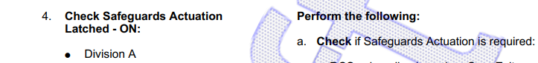

- Print unit 3 FR-H.1
- Verify step 7.a RNO text prints closer to the right page boarder as in the screenshot below:

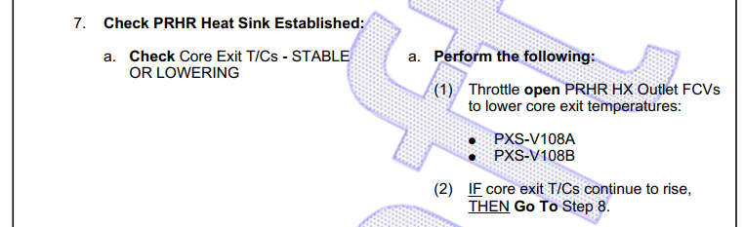

- Verify if the Version number does not print on top of the page number in Attachment 1

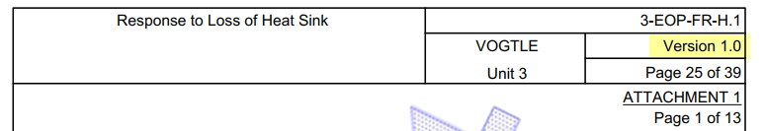

- Print unit 3 EOP-F-0
- Verify all seven attachments use the Attachment Word Editor section

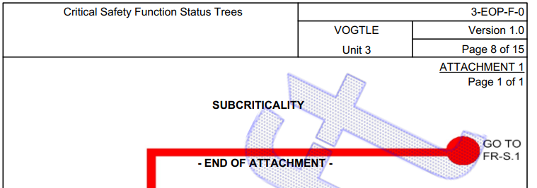

Changes/Additions to PROMS Manual and Training Videos:
[Do not use this section – for MRV/DMJ use]
- CSM submitted for PROMS User Manual: ____________.
- CSM submitted for training videos: ____________.

