3/7/2024

Applicability: F2024-032: Robinson Format (CPL & CPLA) – add section number/title page number transition support

Internal Data Fixes: NA

Internal Release:

F2024-032: Robinson Format (CPL & CPLA) – add section number/title page number transition support

Generic External Release: NA

Plant Specific Information for Release Letter:

Robinson: Section number, section title transitions now allow a page number to be included when printed. To insert this type of transition, using the Step Properties panel, Transition Tab, select the Section Number, Section Title format, check the ‘Include Page Number’ box, select the Attachment and uncheck ‘Include Step Number’.

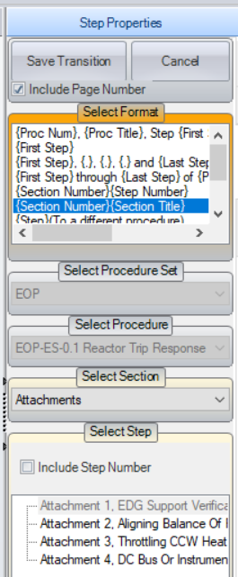

Testing Performed:

See Testing Required.

Testing Requirements:

Using the Robinson sql database:

£ Expand a procedure such as EOP-ES-0.1 and insert a section before the ‘Attachment 1’ section. For this new section: no number, ‘Attachments’ as title. Format is CPL, Step section, Type is ‘Attachment Steps – One Column’ and set Columns to ‘One Column’. Automation is ‘No’ Link Enhanced.
£ Insert a few transitions to Attachment 1, Attachment 2, Attachment 3 and Attachment 4 using the following: use the Step Properties panel, Transition Tab, select the Section Number, Section Title format, check the ‘Include Page Number’ box, select the Attachment and uncheck ‘Include Step Number’. (see image under Plant Specific Information for Release Letter

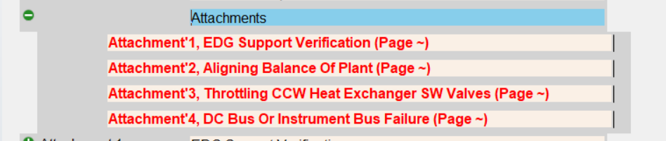

£ Print the procedure to verify that the page number transitions get resolved to the correct page numbers of the Attachment sections

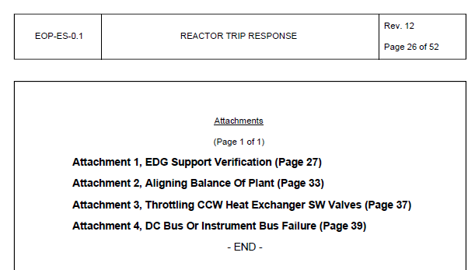

Changes/Additions to User Documentation: NA

