August 11, 2026

Applicability: All

Internal Release Information:
B2026-053 Find Unlinked Values of Selected. When searching for “Unlinked Values of Selected” on the Reference Objects tab in global search and selecting “Find Unlinked Values of Selected” the return values are not an exact match.

- [Check this box if a sql query or a data fix applies to this update].

Generic External Release:
N/A
Plant Specific Information for Release Letter:
N/A
Testing Requirements:
Verify that symbols are displayed correctly in the annotations panel.
- USE the updated baseline program.
- Start the baseline program.
- In the first Browse button navigate to:
- V:\Proms Versions\Test Version\Data to use for testing\C2026-039\20260610_0639_2.2.2502.2808_VEPROMS_BGE_39thru69
- In the second Browse button navigate to:
- V:\Proms Versions\Test Version\Data to use for testing\C2026-039\20260612_0548_2.3.2606.510_VEPROMS_BGE_39thru70
- Once this is done click the Pagination Button to run the report.
- Click any of the lines in the lower panels.
- The error “sequence contains no elements” should not appear.

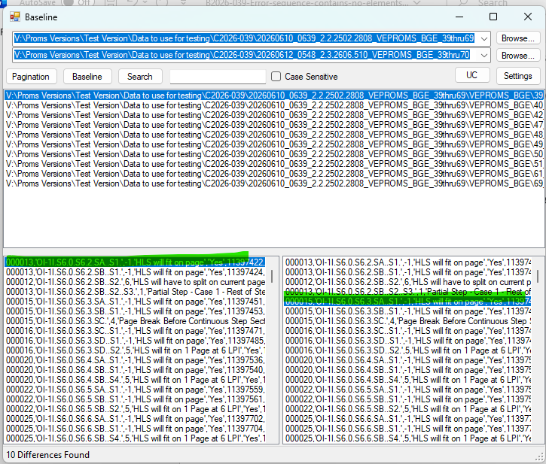

Changes/Additions to PROMS Manual and Training Videos:
[Do not use this section – for MRV/DMJ use]
- CSM submitted for PROMS User Manual: ____________.
- CSM submitted for training videos: ____________.

