June 25, 2026

Applicability: GEN

Internal Release Information:

B2026-052 - Issue when parens inside a Hardspaced Multi-RO Return Values.
PROMS crashes when doing an update ROFst.

Found in Vogtle data.

Contentids:
595101
595103

example: {{A=@HSP((+)0.1 psig)}{B=Containment pressure indicative of an underpressure concern}{C=(P22)}}
- [Check this box if a sql query or a data fix applies to this update].

Generic External Release:
Added ability to be able to have parenthesis inside a Hardspaced Multi-Return RO Value.

Plant Specific Information for Release Letter:
None

Testing Requirements:
- Use Vogtle Data
- Open a EOP Procedure
- Using the RO Editor, change the following setpoint value to contain a parenthesis
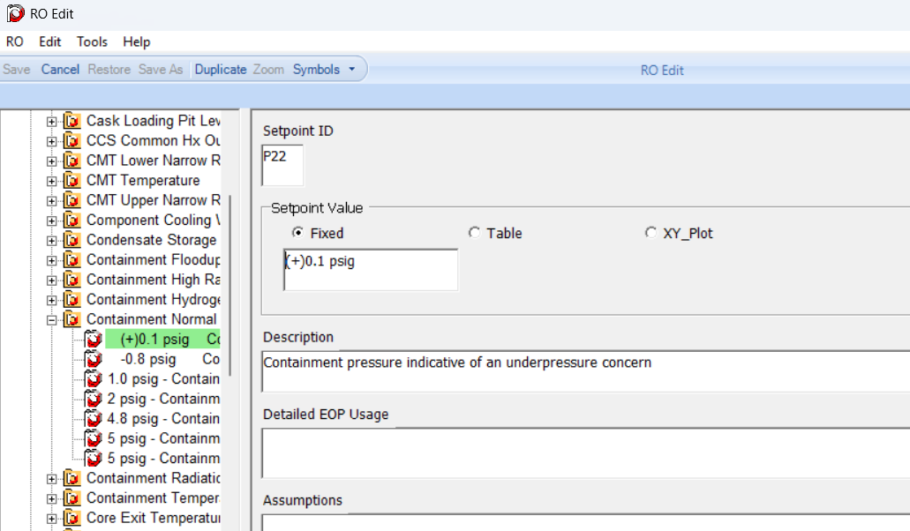
- Generate a RO FST using the RO Editor
- Update the ROs in PROMS
- It should not error out
Current offending RO is:
ContentIDs: 595101, 595103

- Test multiple Hardspaces – Change or create a RO so that it contains multiple @HSP(…) for example:
{{A=@HSP(<Setpoint Value>)}{B=<Description> @HSP(test hardspace)}{C=(<Setpoint ID>)}}
- Generate a RO FST using the RO Editor
- Update the ROs in PROMS
- Add the RO to a step
- Then make a change in the RO Editor to it
- Generate a RO FST using the RO Editor
- Update the ROs in PROMS
- It should not error out

Changes/Additions to PROMS Manual and Training Videos:
[Do not use this section – for MRV/DMJ use]
- CSM submitted for PROMS User Manual: ____________.
- CSM submitted for training videos: ____________.

