8/7/2024

Applicability: VC Summer

Internal Release Information:
F2024-068 VCS Deviation Format.

Create the ability to customize the printout heading from Procedure Set Specific Information dialog box.

No database updates are included in this update.

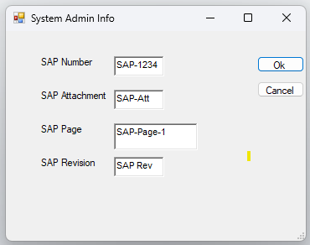

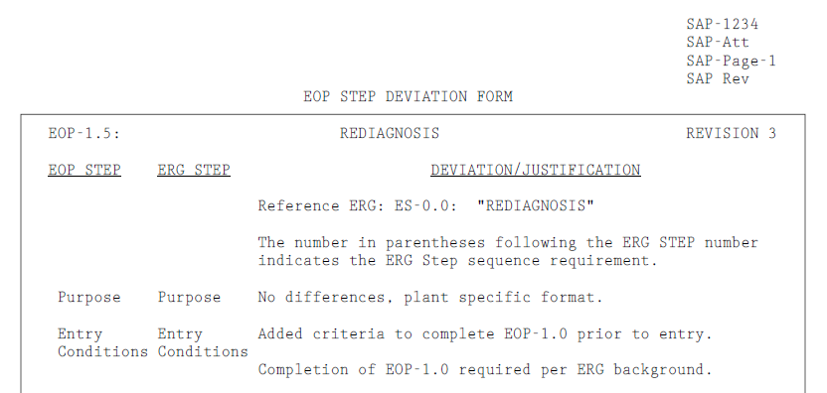

Generic External Release: N/A

Plant Specific Information for Release Letter: N/A
Procedure Set Specific Information dialog box found in the “Working Draft” properties.

Testing Requirements:
- Use VC Summer DB.
- Choose Procedure set “STEP DEVIATION DOCUMENTS”.
- Right click on “Working Draft” and choose “Procedure Set Specific Information”.
- Verify that the pop-up appears with the same fields as pictured above.
- Fill in the fields with some text.
- Right click on Procedure “Rediagnosis” and select “Quick Print”
- Verify that the values you entered appear in the printout header.

Changes/Additions to PROMS Manual and Training Videos:

- CSM submitted for PROMS User Manual: ____________.
- CSM submitted for training videos: ____________.

